4TH OF JULY WEEKEND
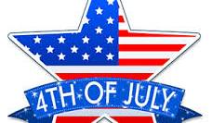
COME CELEBRATE WITH THE
VALLEY TRAIL RIDERS
HOSTS: Lorrie & Terry Busby and Melinda Temple
Franklin Creek State Park Equestrian Area
WEEKEND ACTIVITIES
Dress in red, white & blue
Franklin Creek State Park Equestrian Area

July 4th Trail ride at 10:30am. Potluck at the pavilion at 5:30

July 5th Trail Ride at 10:30am. Dine and Dash 2pm – 4pm at member campsites. You can participate by hosting a camp tour of your campsite and serve a light appetizer and /or beverage

