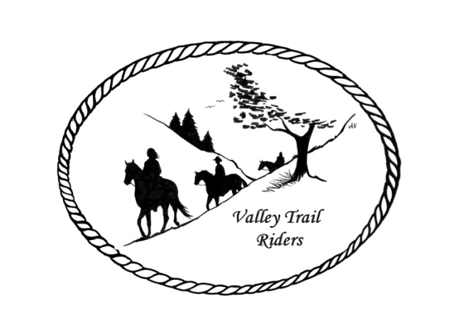

**Valley Trail Riders Minutes**

**November 12, 2024**

The meeting was called to order at 6:52 by President Lorrie Busby. Officers present were President - Lorrie Busby, Secretary - Caron Paschke and Treasurer - Rose Shedd.  There were a total of 14 members present.

We received a thank you card from Winnebago 4H for sponsoring the Senior Trail Class at their show.

**Secretary's Report** - The minutes from the previous meeting were reviewed.  Liz Longenecker made a motion to accept the minutes which was seconded by Cindy Edwards.  The motion passed.

**Treasurer's Report** - There was a previous balance of $1,911.19, income of $1,055.00 and expenses of $1,393.08. The ending checking balance was $1,573.11 (which includes $135.00 in the hand sanitizer fund).  There is $200 cash on hand. Deb Hamilton made a motion to accept the report which was seconded by Chris Darmon and the motion passed.

Reports:

**Rock Cut** - LiaisonTerry Herbig reported that the park has received a grant to repair the doors and roofs of park buildings but it is not known yet when the work will take place.  Matt and Leslie Wheeler will head up a clean-up day on May 17, 2025.

**Forest Preserves** – Liaison Deb Hamilton will report to the County on trails that need to be cleared at Oak Ridge and also that there were no camping forms when we held our event there.  It was requested that she ask about poles being added at Deer Run.  Diane Feuillerat advised that she was told previously that due to vandalism at that park it is day use only and no improvements for camping will be made.

Franklin Creek - We are looking for a volunteer to act as liaison to the park.

**Lockwood Park** – Liaison Rhoda Fox – No report.

**Social Media Committee:**

**Webpage Administrator** - Terry Busby reminded everyone that any pictures submitted from rides will be on the public page.  Another reminder that any ride times submitted must be under the exact name.  You cannot enter some rides under a full name and some under a nickname.  The program recognizes that as two different people and your total numbers will not be correct.  If it does occur Terry will explain how to make the corrections but the member will need to make the corrections themselves.  Terry also thanks those who have made Blog entries.

**Facebook Administrator** - No report.

**Social Media Assistant** - No report.

**Ride Committee** - Liz Longenecker reported the committee will meet in February and will try to have the completed ride pamphlet done in March.  She also thanked everyone who hosted an event this year.

**Club Apparel** - Rose Shedd has shirts and hats available.

**Social Committee** - No report.

**Christmas Committee** - Looking for donations for the silent auction at the Christmas party.

**Miles by the Minute Program**- Anyone who has not entered for 2024 may still join until Feb. 1.  Hours must be submitted by Nov. 1.  Badges earned this year will be presented at the Christmas party.  Donna Howland made a motion to change the entry fee to $25.00 for the first year and $15.00 for subsequent years and also that badges will be presented at the year-end party.  Cindy Edwards seconded the motion.  The motion passed.  Donna Howland made a second motion to make entry fees due by January 31st (the same date yearly club dues are due).  Chris Darmon seconded the motion.  The motion passed.  Hours for badges must be reported to Melissa Myers by the member.

**Committees for 2025 approved by the membership:**

Christmas Party: Chair - Caron Paschke, Yvonne Comm, Rose Shedd, Susan Krug, and Debbi Hamilton.

Ride Committee: Chair - Liz Longenecker, Donna Howland, Cindy Edwards, Melissa Myers and Chris Darmon.

Social Committee: Chair - Yvonne Comm, Lorrie Busby and Diane Feuillerat

There was no Old Business brought up for discussion. New Business: Elections were held for Officers for 2025.  The results were President - Lorrie Busby, Vice-President, Yvonne Comm; Secretary, Caron Paschke and Treasurer, Rose Shedd. Elections were also held for Board of Directors for 2025.  Elected were Donna Howland, Diane Feuillerat and Sharon  Vonderheide.

Kerry Fagerstrom made a motion to adjourn the meeting which was seconded by Terry Busby.  The motion passed. The meeting was adjourned at 7:57pm.