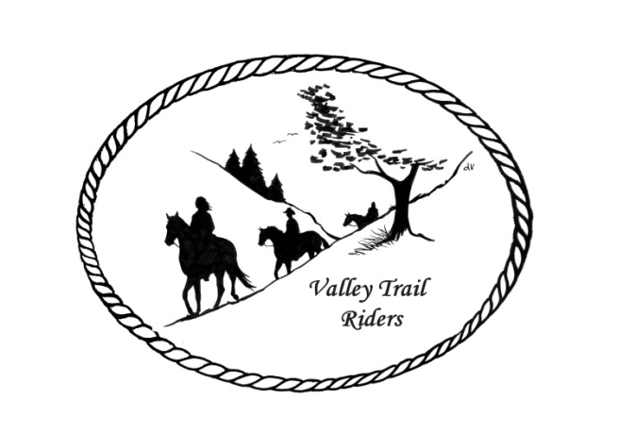 | December 2024 Newsletter

VALLEY TRAIL RIDERS CLUB NEWS
Our year is coming to a close and our last riding event, the VTR's Flannel Shirt Ride had a great turnout of 15 riders! Everyone was decked out in their flannel apparel. We had an adventurous Ride with an unexpected twist! Afterwards, we had a great "soup" potluck with a big, warming campfire! We won't mention the FIREBALL that was used later on to warm up!
See committee members listed at the end of the Newsletter. It’s not too late to join a committee!!!
Christmas party is next on December 7th – get ready for a great evening of dinner, dancing, and door prizes!!
Officers for 2025: President -Lorrie Busby (815-973-2192); Vice President -Yvonne Comm; Secretary - Caron Paschke; Treasurer - Rose Shedd
Club Board of Directors for 2025: Diane Feuillerat, Sharon Vonderheide, and Donna Howland

Any questions or concerns can be directed to an officer or director at any time.
DUES - Single -$15.00 & Family-$20.00
Make checks payable to Valley Trail Riders and mail to: Rose Shedd, 6744 Freeport Road, Rockton, IL 61072-9426
Current member’s dues are due by January 31, 2025 A good time to pay your dues is at the Christmas Party. Rose will be at the check in table at the Christmas Party. Please bring checks only.

Liaisons to our local parks:
Rock Cut State Park: Terry Herbig – To report any problems at the park call 815-979-1237
Franklin Creek State Park: NEED VOLUNTEER & Winnebago Forest Preserves: Debbi Hamilton

Club Website Manager – Terry Busby --To contact Terry, please go to the website and click on support or email support@ valleytrailriders.club.

The website address is: www.Valleytrailriders.club
To access the members-only side of the website, Click on the join button--Fill out the form --Click the Submit button. This area includes: Area to submit Blog articles, club newsletter and meeting minutes, Member contacts and Club Bylaws. If you have not done so yet, please go on our website and create your member log in. Terry will approve your access to the “Members Only” section once he verifies your paid membership. When you are approved, you will be set up with your own club email address that links to your personal email address.

Facebook Page Administrator- Kurtis Longenecker -- Please forward anything you want posted, such as pictures or events on our page to Kurtis at k_longenecker@valleytrailriders.club
There is an area to do a review on our Facebook Page. Please consider entering one!

Valley Trail Riders Apparel-You can purchase hats, t-shirts, sweatshirts, etc…by contacting Rose Shedd at 815-979-5998 - Rose also brings items for sale, to our club meetings😊

Calendar
- Christmas Party is on 12/7/2024 at the Byron Forest Preserve Nature Center.
- January Meeting on the 14th at the Lockwood Cookhouse @ 6:30. It is located at 5201 Safford Road, Rockford
- February Meeting on the 11th at the Lockwood Cookhouse @ 6:30. It is located at 5201 Safford Road, Rockford
- March Meeting on the 11th at the Lockwood Cookhouse @ 6:30. It is located at 5201 Safford Road, Rockford
- April Meeting on the 8th at the Lockwood Cookhouse @ 6:30. It is located at 5201 Safford Road, Rockford
- May Meeting on the 13th at the Lockwood Cookhouse @ 6:30. It is located at 5201 Safford Road, Rockford

Committee Members:

Christmas Party: Caron Paschke (Chair), Debbi Hamilton, Yvonne Comm, Rose Shedd, and Susan Krug

Social Committee: Yvonne Comm (Chair), Diane Feuillerat, and Lorrie Busby

Ride Committee: Liz Longenecker (Chair), Donna Howland, Cindy Edwards, Melissa Myers, and Chris Darmon

Social Media Committee: Webpage Administrator-Terry Busby; FaceBook Page Administrator– Kurtis Longenecker; Media Assistant -Melissa Myers

Ad Hoc Committee: (Associate Memberships) – Melissa Meyers (Chair), Lorrie Busby, Caron Paschke, Chris Darmon, and Terry Busby.
Annual Year End Awards
Award Categories: (1) Most Hours in the Saddle or Driving a cart (hours include #2), (2) Most Hours in the saddle or driving a cart at VTR Hosted Events, (3) Most Active Event Organizer/Committee Member/Board Member/Officer, (4) New Member Recruitment, (5) Website Blog Activity and Finally
(6) Member of The Year based on points accumulated from the 5 categories listed above.

All VTR members are automatically eligible for this program upon payment of your annual membership dues. Points from the above categories are calculated and assigned points based on the 12 month period from November 1st to October 31st. Each of the (5) categories is awarded to first and second place. Please use the website https://valleytrailriders.club to self-report hours and activities by November 15th of each year. An alternative manual form is available on the website or from the ride committee. Please contact Donna Howland at 815-222-7345 should you require assistance.

