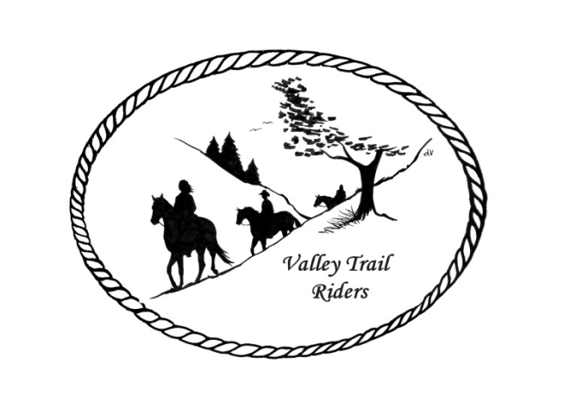 | November 2024 Newsletter

VALLEY TRAIL RIDERS CLUB NEWS

We will be back at the Lockwood Cookhouse for our winter meetings. It is located at 5201 Safford Road, Rockford. Meeting is at 6:30. Bring a snack to share if you like. The Christmas Party Committee is still gathering items for the silent auction and door prizes, so please reach out to stores and businesses to ask for donations. If you have items that you no longer need that are in excellent shape, these may also be donated. Please bring any donations you may have to the November meeting or contact one of the committee members to arrange for pick up. We will be putting together a collection of photos of club events and members throughout the 2024 year to be played on a large screen at the party. If you have any photos to share, please submit them to Sue Krug via email at Skrug@Valleytrailriders.Club

The election of officers will be held at the November meeting. If you wish to run for an office or nominate someone, please let Lorrie know before the meeting. Nominations will be opened up to the floor as well. We will also be filling our committees for the coming year. If you are interested in serving on a committee, please feel free to reach out to current committee members and ask questions about what is involved in serving on their committees. We do know that we will need a chair person for the social committee.

Our Halloween Spooktacular was a really fun event! We had a really great costume contest and the participants really went all out! Demelza Butts was our judge with some help from her mother, Charity Littlefield Butts! We had a really great Spooky Trail Ride (14 riders) with Trick or Treating on the trail and lots of candy to be had by all! We had an excellent Halloween potluck with really scary food like Fried Bat and Ghooouuulosh! We ended the day’s activities with a huge, beautiful, campfire!

Check out the calendar for the events to conclude 2024.

Officers:
President – Lorrie Busby (815-973-2192)
Vice President – Yvonne Comm
Secretary – Caron Paschke

Treasurer – Rose Shedd

Club Board of Directors: Diane Feuillerat, Susan Krug, and Donna Howland

Any questions or concerns can be directed to an officer or director at any time.
DUES - Single -$15.00 & Family-$20.00
Make checks payable to Valley Trail Riders and mail to:
Rose Shedd, 6744 Freeport Road, Rockton, IL 61072-9426
Current member’s dues are due by January 31, 2025 A good time to pay your dues is at the Christmas Party. Rose will be at the check in table at the Christmas Party. Please bring checks only.

Liaisons to our local parks:
Rock Cut State Park: Terry Herbig – To report any problems at the park call 815-979-1237
Franklin Creek State Park: Diane Croom & Winnebago Forest Preserves: Debbi Hamilton

Club Website Manager – Terry Busby --To contact Terry, please go to the website and click on support or email support@ valleytrailriders.club.

The website address is: www.Valleytrailriders.club
To access the members-only side of the website, Click on the join button--Fill out the form --Click the Submit button. This area includes: Area to submit Blog articles, club newsletter and meeting minutes, Member contacts and Club Bylaws. If you have not done so yet, please go on our website and create your member log in. Terry will approve your access to the “Members Only” section once he verifies your paid membership. When you are approved, you will be set up with your own club email address that links to your personal email address.

Facebook Page Administrator- Kurtis Longenecker -- Please forward anything you want posted, such as pictures or events on our page to Kurtis at k_longenecker@valleytrailriders.club

Valley Trail Riders Apparel-You can purchase hats, t-shirts, sweatshirts, etc…by contacting Rose Shedd at 815-979-5998 - Rose also brings items for sale, to our club meetings😊

Calendar

- Flannel Shirt Ride 11/9/2024 @ Oakridge Forest Preserve, 8322 Blomberg Road, Cherry Valley, IL
Ride at 12 noon and 4:30 potluck dinner.

- Club Meeting 11/12/2024 at the Lockwood Cookhouse @ 6:30. It is located at 5201 Safford Road, Rockford. Bring a snack to share if you like. Election of officers and appointment of committee members.

- Christmas Party is on 12/7/2024 at the Byron Forest Preserve Nature Center. There will be a band, catered food, silent auction, and door prizes. Year-end awards are also given out at the party. You may invite guests for the entire evening this year. Reservations of $30 per person are due by November 18th.

Committee Members:

Christmas Party: Debbi Hamilton, Lorrie Busby, Darcy Cross, Yvonne Comm, Rose Shedd, Susan Krug, Caron Paschke

Social Committee: Chair-Nora Clapsaddle, Diane Feuillerat, Yvonne Comm, and Darcy Cross

Ride Committee: Chair-Liz Longenecker, Donna Howland, Cindy Edwards, Melissa Myers, Janeen Latta, and Chris Darmon

Social Media Committee: Webpage Administrator-Terry Busby; FaceBook Page Administrator– Kurtis Longenecker, and Melissa Myers

Ad Hoc Committee: Associate Memberships – Melissa Meyers Chair, Lorrie Busby, Caron Paschke, Chris Darmon, and Terry Busby.

