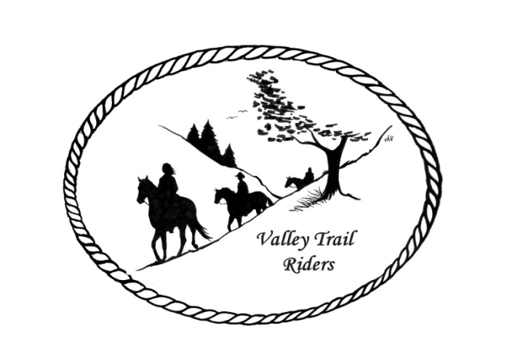 | October 2024 Newsletter

VALLEY TRAIL RIDERS CLUB NEWS
The Valley Trail Riders had their annual Steak Fry, which was a big hit as always. Thanks to Caron, Liz, Janeen and Rose for making it such a wonderful event. The food was delicious and steaks were cooked to perfection!! We also incorporated a new event called Dine n Dash this year where VTR members opened up their campers/campsite to others to view and provided a snack and a drink. It was lots of fun!!

Remember to log your rides on the website, for our year end awards. We will not be having an October meeting, so maybe you can use that extra time to get your rides and driving hours logged since the deadline for the year is October 31st. The new ride program also accumulates hours in the saddle for a badge based on those cumulative hours. For more information on the ride program, ask anyone from the ride committee.

The Christmas Party Committee is still gathering items for the silent auction and door prizes. Please reach out to stores and businesses to ask for donations. We do have a form letter, if you would like to hand them something when asking. It can be forwarded through email, just contact Lorrie Busby.

The election of officers is at the November meeting. If you wish to run for an office or nominate someone, please let Lorrie know before the meeting. Nominations will be opened up to the floor as well.

Check out the calendar for the events to conclude the riding season.

Officers:
President – Lorrie Busby (815-973-2192)
Vice President – Yvonne Comm
Secretary – Caron Paschke

Treasurer – Rose Shedd

Club Board of Directors: Diane Feuillerat, Susan Krug, and Donna Howland

Any questions or concerns can be directed to an officer or director at any time.
DUES - Single -$15.00 & Family-$20.00
Make checks payable to Valley Trail Riders and mail to: Rose Shedd, 6744 Freeport Road, Rockton, IL 61072-9426.

Liaisons to our local parks:

Rock Cut State Park: Terry Herbig – To report any problems at the park call 815-979-1237
Franklin Creek State Park: Diane Croom & Winnebago Forest Preserves: Debbi Hamilton & Nora Clapsaddle

Club Website Manager – Terry Busby --To contact Terry, please go to the website and click on support or email support@ valleytrailriders.club.
The website address is: www.Valleytrailriders.club
To access the members-only side of the website, Click on the join button--Fill out the form --Click the Submit button. This area includes: Area to submit Blog articles, club newsletter and meeting minutes, Member contacts and Club Bylaws. If you have not done so yet, please go on our website and create your member log in. Terry will approve your access to the “Members Only” section once he verifies your paid membership. When you are approved, you will be set up with your own club email address that links to your personal email address.

Facebook Page Administrator- Kurtis Longenecker -- Please forward anything you want posted, such as pictures or events on our page to Kurtis at k_longenecker@valleytrailriders.club

Valley Trail Riders Apparel-You can purchase hats, t-shirts, sweatshirts, etc…by contacting Rose Shedd at 815-979-5998 - Rose also brings items for sale, to our club meetings😊

Calendar

- Pony Cart and Wagon Demo – 9/28/24 @Cindy Edwards Pony Farm. 1921 Genoa Rd., Belvidere, IL @1 pm. Demo, Supper, and bonfire. National Good Neighbor Day!!

- Chili Dump 10/5/24 @ Seward Bluffs Ride at 1 pm and potluck dinner 5:30 pm. Bring enough Chili for your family/group, to dump and a dish to pass.

- Halloween Scary Ride 10/19/24 @ Rock Cut State Park Equestrian Area. 12:30 pm Scary costume contest; 1 pm Trick or Treat Trail Ride; 5 pm ghoulish potluck. Boo!!

- Flannel Shirt Ride 11/9/24 @ Rock Cut State Park Equestrian Area. Ride at 12 noon and 4:30 potluck dinner.

- Christmas Party is on December 7th at the Byron Forest Preserve Nature Center. There will be a band, catered food, silent auction, and door prizes. Year-end awards are also given out at the party. A flyer will be out this month to all members with all the details.

Committee Members:

Christmas Party: Debbi Hamilton, Lorrie Conry, Darcy Cross, Yvonne Comm, Rose Shedd, Susan Krug, Caron Paschke

Social Committee: Chair-Nora Clapsaddle, Diane Feuillerat, Yvonne Comm, and Darcy Cross

By Laws Committee: Nora Clapsaddle, Marti Files, Debbi Hamilton, Yvonne Comm, Susan Krug

Ride Committee: Chair-Liz Longenecker, Donna Howland, Cindy Edwards, Donna Meyer, Melissa Myers, Janeen Latta, and Chris Darmon

Social Media Committee: Webpage Administrator-Terry Busby; FaceBook Page Administrator– Kurtis Longenecker, and Helper Melissa Myers

Ad Hoc Committee: Associate Memberships – Melissa Meyers Chair, Lorrie Busby, Caron Paschke, Chris Darmon, and Terry Busby.

