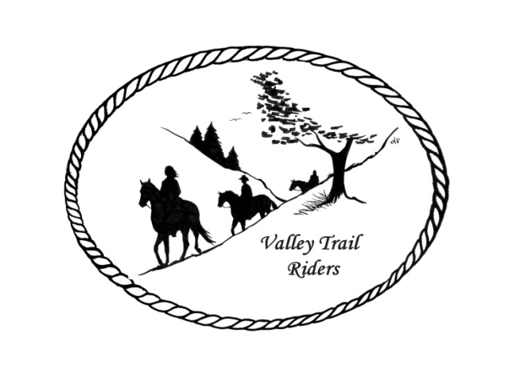 | August 2024 Newsletter

VALLEY TRAIL RIDERS CLUB NEWS

The Christmas in July and obstacle course event was held in July at Rock Cut. It was a very hot weekend, but a few brave souls came out to enjoy the event. The pork chop dinner was yummy and the obstacle course was so much fun. Thanks to Liz Longenecker and the ride committee for creating such a fun weekend.

Remember to log your rides on the website, for our year end awards.

A few Valley Trail Riders went to Wildcat Mountain and Kickapoo forest near Ontario, Wisconsin to ride and had a great time. It would be a great place at End of the Trail campground, for our club to hold a far away ride!!

Check out the calendar for the events to conclude the riding season.

Officers:
President – Lorrie Conry (815-973-2192)
Vice President – Yvonne Comm
Secretary – Caron Paschke

Treasurer – Rose Shedd

Club Board of Directors: Diane Feuillerat, Susan Krug, and Donna Howland

Any questions or concerns can be directed to an officer or director at any time.
DUES - Single -$15.00 & Family-$20.00
Make checks payable to Valley Trail Riders and mail to: Rose Shedd, 6744 Freeport Road, Rockton, IL 61072-9426.
Liaisons to our local parks:

Rock Cut State Park: Terry Herbig – To report any problems at the park call 815-885-3311

Franklin Creek State Park: Diane Croom

Winnebago Forest Preserves: Debbi Hamilton & Nora Clapsaddle

Club Website Manager – Terry Busby --To contact Terry, please go to the website and click on support or email support@ valleytrailriders.club.
The website address is: www.Valleytrailriders.club
To access the members-only side of the website, Click on the join button--Fill out the form --Click the Submit button. This area includes: Area to submit Blog articles, club newsletter and meeting minutes, Member contacts and Club Bylaws. If you have not done so yet, please go on our website and create your member log in. Terry will approve your access to the “Members Only” section once he verifies your paid membership. When you are approved, you will be set up with your own club email address that links to your personal email address.

Facebook Page Administrator- Kurtis Longenecker -- Please forward anything you want posted, such as pictures or events on our page to Kurtis at k_longenecker@valleytrailriders.club

Valley Trail Riders Apparel-You can purchase hats, t-shirts, sweatshirts, etc…by contacting Rose Shedd at 815-979-5998 - Rose also brings items for sale, to our club meetings😊

Calendar

- August 13, 2024 - Club Meeting @ the Busby’s Barn at 6:30 pm, 10538 N. Pecatonica Road, Leaf River, IL. Bring a snack to share if you like. There is an entrance to the south of our home, to park out by the barn.

- August 24, 2024 Survivor event was canceled but the ride committee created a new event - Round up that clue and name that tune @ Franklin Creek State Park Equestrian area. Riders will go out between 10:00 a.m. and 2:30 p.m. to round up song lyric clues in order to name the tune. There will be a potluck at 5:30 p.m. The club will provide the main dish and dinnerware, please bring a dish to pass and your own beverage .Cindy Edwards and Donna Howland are hosting the riding event, and Chris Hyser Darmon and Melissa Hyser Myers are hosting the potluck. More information will be available closer to the event.

- Steak Fry 9/14/24 @Rock Cut State Park Equestrian Area. Ride at 1 pm and dinner at 5:30 pm; 50/50 raffle. Price of dinner to be determined later.

- Pony Cart and Wagon Demo – 9/28/24 @Cindy Edwards Pony Farm. 1921 Genoa Rd., Belvidere, IL @1 pm. Demo, Supper, and bonfire. National Good Neighbor Day!!

- Chili Dump 10/5/24 @ Franklin Creek State Park Equestrian Area. Ride at 1 pm and potluck dinner 5:30 pm. Bring some Chili to dump and a dish to pass.

- Halloween Scary Ride 10/19/24 @ Rock Cut State Park Equestrian Area. 12:30 pm Scary costume contest; 1 pm Trick or Treat Trail Ride; 5 pm ghoulish potluck. Boo!!

- Flannel Shirt Ride 11/9/24 @ Rock Cut State Park Equestrian Area. Ride at 12 noon and 4:30 potluck dinner.

