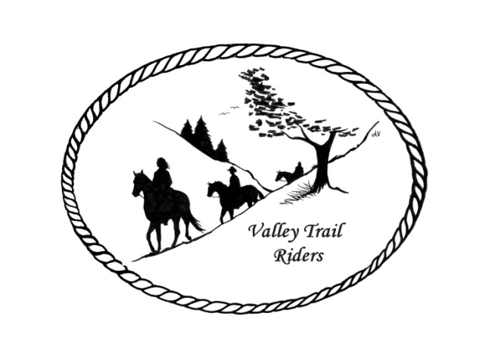 | July 2024 Newsletter

VALLEY TRAIL RIDERS CLUB NEWS

Since everyone is out riding and camping, we did not have a June Meeting. Summer is a time of year, where there is not a lot of club business, especially since we have our events and activities planned ahead. We will have a club meeting in July, so check the dates out below on our calendar.

On June 8th the club held a trail ride at Rock Cut State Park. It was not a very nice day, but three brave souls rode out at 1 pm, and got soaked. The potluck was a success as usual though😊 and there was a fabulous campfire afterwards where everyone learned about making S’mores in a bag. The Obstacle course event got rescheduled due to extreme heat. Check out to the calendar for the events to conclude the riding season.

An ad hock committee will be working on replacing the lattice at the shelter at Rock Cut and other repairs needed.

Officers:
President – Lorrie Conry (815-973-2192)
Vice President – Yvonne Comm
Secretary – Caron Paschke

Treasurer – Rose Shedd

Club Board of Directors: Diane Feuillerat, Susan Krug, and Donna Howland

Any questions or concerns can be directed to an officer or director at any time.
DUES - Single -$15.00 & Family-$20.00
Make checks payable to Valley Trail Riders and mail to: Rose Shedd, 6744 Freeport Road, Rockton, IL 61072-9426.
Liaisons to our local parks:

Rock Cut State Park: Terry Herbig – To report any problems at the park call 815-885-3311

Franklin Creek State Park: Diane Croom

Winnebago Forest Preserves: Debbi Hamilton & Nora Clapsaddle

Club Website Manager – Terry Busby --To contact Terry, please go to the website and click on support or email support@ valleytrailriders.club.
The website address is: www.Valleytrailriders.club
To access the members-only side of the website, Click on the join button--Fill out the form --Click the Submit button. This area includes: Area to submit Blog articles, club newsletter and meeting minutes, Member contacts and Club Bylaws. If you have not done so yet, please go on our website and create your member log in. Terry will approve your access to the “Members Only” section once he verifies your paid membership. When you are approved, you will be set up with your own club email address that links to your personal email address.

Facebook Page Administrator- Kurtis Longenecker -- Please forward anything you want posted, such as pictures or events on our page to Kurtis at k_longenecker@valleytrailriders.club

Valley Trail Riders Apparel-You can purchase hats, t-shirts, sweatshirts, etc…by contacting Rose Shedd at 815-979-5998 - Rose also brings items for sale, to our club meetings😊

Calendar
- July 9, 2024 - Club Meeting @ the Busby’s Barn at 6:30 pm. Potluck dinner before meeting. 10538 N. Pecatonica Road, Leaf River, IL. There is an entrance to the south of our home, to park out by the barn.

- Obstacle Course Challenge at Rock Cut Equestrian Park @ 10 am; Potluck dinner at 5:30pm; 50/50 raffle. Rescheduled to coincide with the Christmas in July event 7/13/2024

- Christmas in July 7/13/24 @ Rock Cut State Park Equestrian area. 10 am – 12 noon Christmas activities; 1pm Christmas Dress up Parade Contest. 1:30 pm Candy Cane Lane Trail Ride; 5:30 pm Potluck dinner. 6:30 pm White Elephant Gift Exchange and 50/50 raffle. Come and let your inner child out!!

- Shedd Farm Members Only ride - July 20 & 21st. Please RSVP by July 13th to Rose if you are planning on camping and the dinner on the 20th. They need to know how many horses will be overnight and how many people eating dinner on the 20th. At this time the water is high and event is questionable. We will keep you updated.

- Survivor – Members only (Sign up required) - 8/24/24 @ Franklin Creek State Park Equestrian area. Meet in the arena @9 am. Event starts at 9:30 am. We will break at noon for lunch. 1 pm Scavenger hunt ride for points; 4 pm fire making challenge; 5 pm crown winners; 5:30 pm potluck dinner and 50/50 raffle. WHO WILL BE THE LONE SURVIVOR?!

- Steak Fry 9/14/24 @Rock Cut State Park Equestrian Area. Ride at 1 pm and dinner at 5:30 pm; 50/50 raffle. Price of dinner to be determined later.

- Pony Cart and Wagon Demo – 9/28/24 @Cindy Edwards Pony Farm. 1921 Genoa Rd., Belvidere, IL @1 pm. Demo, Supper, and bonfire. National Good Neighbor Day!!

- Chili Dump 10/5/24 @ Franklin Creek State Park Equestrian Area. Ride at 1 pm and potluck dinner 5:30 pm. Bring some Chili to dump and a dish to pass.

- Halloween Scary Ride 10/19/24 @ Rock Cut State Park Equestrian Area. 12:30 pm Scary costume contest; 1 pm Trick or Treat Trail Ride; 5 pm ghoulish potluck. Boo!!

- Flannel Shirt Ride 11/9/24 @ Rock Cut State Park Equestrian Area. Ride at 12 noon and 4:30 potluck dinner.

