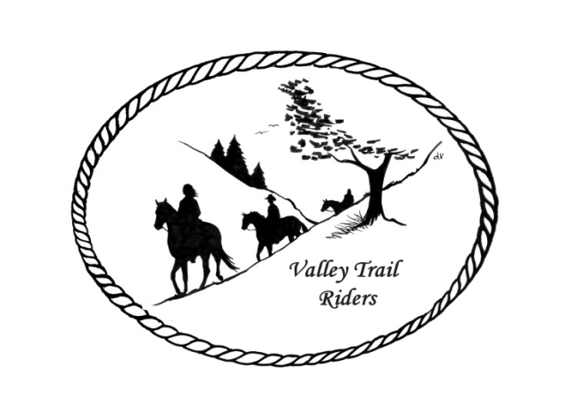 | May 2024 Newsletter

VALLEY TRAIL RIDERS CLUB NEWS
We welcomed new members John and Sue Reitmeier to our club membership at the April meeting. We also enjoyed a presentation by Mary Hougan owner of Equi Stroke for horses. Mary shared valuable information on treatments and different modalities she uses to keep our equine partners in the best shape mentally and physically. She also handed out directions for doing carrot stretches with our horses. Thanks to the Social Committee for arranging speakers for our meetings.

The ride committee has created a brochure with all the club events for the 2024 riding season. If you have not gotten one, please contact Liz Longenecker or anyone from the ride committee.

I called Franklin Creek State park this morning (4-25) and they are still advising to avoid the creek and definitely do not let your animals drink from it. The wells have been cleared for use in the equine campground. At this time the park is open.

DUES - Single -$15.00 & Family-$20.00
Make checks payable to Valley Trail Riders and mail to: Rose Shedd, 6744 Freeport Road, Rockton, IL 61072-9426.

Officers:
President – Lorrie Conry (815-973-2192)
Vice President – Yvonne Comm
Secretary – Caron Paschke
Treasurer – Rose Shedd

Club Board of Directors: Diane Feuillerat, Susan Krug, and Donna Howland

Any questions or concerns can be directed to an officer or director at any time.
Liaisons to our local parks:

Rock Cut State Park: Terry Herbig – To report any problems at the park call 815-885-3311

Franklin Creek State Park: Diane Croom

Winnebago Forest Preserves: Debbi Hamilton & Nora Clapsaddle

Club Website Manager – Terry Busby --To contact Terry, please go to the website and click on support or email support@ valleytrailriders.club.
The website address is: www.Valleytrailriders.club
To access the members-only side of the website, Click on the join button--Fill out the form --Click the Submit button. This area includes: Area to submit Blog articles, club newsletter and meeting minutes, Member contacts and Club Bylaws. If you have not done so yet, please go on our website and create your member log in. Terry will approve your access to the “Members Only” section once he verifies your paid membership. When you are approved, you will be set up with your own club email address that links to your personal email address.

Facebook Page Administrator- Kurtis Longenecker -- Please forward anything you want posted, such as pictures or events on our page to Kurtis at k_longenecker@valleytrailriders.club

Valley Trail Riders Apparel-You can purchase hats, t-shirts, sweatshirts, etc…by contacting Rose Shedd at 815-979-5998 - Rose also brings items for sale, to our club meetings😊

Calendar

- April 27, 2024 Cinco De Mayo ride at Rock Cut State Park Equestrian Area – 1pm Fast Ride and Slow Ride groups going out. Mexican food potluck at 5:30pm. (VTR providing tacos) Camp, Ride, Eat!! This will be our first event of the season. Rain or shine. Hope to see you all there!!

- May 4, 2024 Derby Day at the Donna Howland home (9370 Lawrenceville Road, Garden Prairie, IL) at 2pm- Menu includes: Sloppy Joes, Cheesy Potatoes, salad, water. Please bring your own adult beverage. Fun and games/competitions, before and after the Derby race. Simple betting on first place derby winner, $5 increments. Best dressed derby outfit competition. Indoor arena may be used for games, please bring appropriate shoes for sand.

- May 14, 2024 Club meeting at the Cook House at Lockwood Park -6:30 p.m. Mental Health and Wellness – the role animals play; Mental Health Nurse Practitioner and accomplished horsewoman on the benefits of animals in our mental health. Bring a snack to share if you like.

- May 25, 2024 Poker Run at Franklin Creek State Park Equestrian area @10am -2pm with cash prizes. Pulled Pork lunch at noon $5.50 – 50/50 raffle. Call 815-751-3868 for more details.

- May 27, 2024 Pecatonica Memorial Day Parade – 12 noon float decorating party. The parade is at 2pm. Bring candy to throw out.

- June 8, 2024 Tack Sale at Rock Cut Equestrian Park. Set up 8am; Sale 9am – noon; Ride 1pm; Potluck at 5:30; 50/50 raffle.

- June 22, 2024 Obstacle Course Challenge at Rock Cut Equestrian Park @ 10 am; Potluck dinner at 5:30pm; 50/50 raffle.
- There will be no June club meeting.

