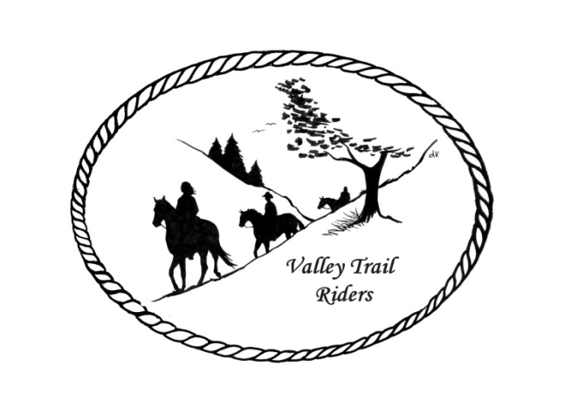 | April 2024 Newsletter

VALLEY TRAIL RIDERS CLUB NEWS

This month marks the beginning of our riding and camping season---WooHoo!! Our first ride is the last weekend of the month celebrating Cinco De Mayo. Please check in with Susan Krug to sign up for extras for our Mexican Fiesta. Midwest Horse Fair is also this month on the weekend of the 19th. Hope to catch up with many of you there.
There has been a lot of work done at Franklin Creek Park to get it ready for trail riding, so please thank those who volunteered if you get the chance. There is another work day scheduled for April 6th, see posts on Face Book about it. Diane Croom is our new liaison to the park and she has been involved a couple work days already!
We are signed up for a float at the Pecatonica Parade on Memorial Weekend. Please bring a bag of candy to one of the next two meetings, for float riders to throw out to the crowd if you are able. Liz will be getting information out to club members about decorating and participating with the float. The ride committee also created a wonderful brochure with all our activities for the year. If you did not get one at the last meeting, check with Liz Longenecker, or get yours at the April Meeting.
We will be having another guest speaker at the April meeting, thanks to the Social Committee! Please check the calendar at the end of the newsletter for details and other upcoming events.

DUES - Single -$15.00 & Family-$20.00
Make checks payable to Valley Trail Riders and mail to: Rose Shedd, 6744 Freeport Road, Rockton, IL 61072-9426.

Officers:
President – Lorrie Conry (815-973-2192)
Vice President – Yvonne Comm
Secretary – Caron Paschke
Treasurer – Rose Shedd

Club Board of Directors: Diane Feuillerat, Susan Krug, and Donna Howland

Any questions or concerns can be directed to an officer or director at any time.
Liaisons to our local parks:

Rock Cut State Park: Terry Herbig – To report any problems at the park call 815-885-3311

Franklin Creek State Park: Diane Croom

Winnebago Forest Preserves: Debbi Hamilton & Nora Clapsaddle

Club Website Manager – Terry Busby --To contact Terry, please go to the website and click on support or email support@ valleytrailriders.club.
The website address is: www.Valleytrailriders.club
To access the members-only side of the website, Click on the join button--Fill out the form --Click the Submit button. This area includes: Area to submit Blog articles, club newsletter and meeting minutes, Member contacts and Club Bylaws. If you have not done so yet, please go on our website and create your member log in. Terry will approve your access to the “Members Only” section once he verifies your paid membership. When you are approved, you will be set up with your own club email address that links to your personal email address.

Facebook Page Administrator- Kurtis Longenecker -- Please forward anything you want posted, such as pictures or events on our page to Kurtis at k_longenecker@valleytrailriders.club

Valley Trail Riders Apparel-You can purchase hats, t-shirts, sweatshirts, etc…by contacting Rose Shedd at 815-979-5998 - Rose also brings items for sale, to our club meetings😊

Calendar

- April 9, 2024 Club meeting at the Cook House at Lockwood Park -6:30 p.m. Equi-Stroke owner and practitioner, Mary Hougan (Certified Equine Massage Therapist) to present ideas on equine bodywork. Bring a snack to share if you like.

- April 27, 2024 Cinco De Mayo ride at Rock Cut State Park Equestrian Area – 1pm Fast Ride and Slow Ride groups going out. Mexican food potluck at 5:30pm – Sign-up sheet for condiments.

- May 4, 2024 Derby Day at the Donna Howland home at 2pm. More details to come via Face Book.

- May 14, 2024 Club meeting at the Cook House at Lockwood Park -6:30 p.m. Mental Health and Wellness – the role animals play; Mental Health Nurse Practitioner and accomplished horsewoman on the benefits of animals in our mental health.

