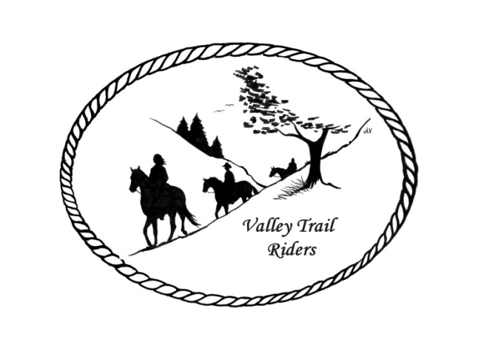 | March 2024 Newsletter

VALLEY TRAIL RIDERS CLUB NEWS
We covered a lot of ground at our February meeting! We began our evening with some sweet treats brought by club members and then opened the meeting by introducing and welcoming new members: Janeen Latta (returning member), Melissa Myers & family, and Lori Brose. A thank you was also given with round of applause for the game day at the Comm home and the game day coming up at the Busby/Conry home. Both game days were well attended and a lot of fun was had by all.
We also thanked Terry Busby for handling the purchase of our new projector and screen for the club. This will be used for many things including presentations at club meetings, movie nights at rides and for our annual banquet.

Our committees had full reports of many events planned for 2024 for meeting presentations with guest speakers, social events, and rides. We have a full calendar for 2024!! The ride committee is finalizing a brochure of the events. Watch your calendar at the bottom of this newsletter each month also. The Christmas party committee has booked the Forest Preserve and the band again for 2024. The By Laws committee made recommendations for many changes to our By Laws to make it more appropriate for the current times and the way we actually conduct the business of the club. You will receive your copy of this in the mail.

DUES - Single -$15.00 & Family-$20.00
Make checks payable to Valley Trail Riders and mail to: Rose Shedd, 6744 Freeport Road, Rockton, IL 61072-9426.

Officers:
President – Lorrie Conry (815-973-2192)
Vice President – Yvonne Comm
Secretary – Caron Paschke
Treasurer – Rose Shedd

Club Board of Directors: Diane Feuillerat, Susan Krug, and Donna Howland

Any questions or concerns can be directed to an officer or director at any time.

Liaisons to our local parks:

Rock Cut State Park: Terry Herbig – To report any problems at the park call 815-885-3311

Franklin Creek State Park: Lorrie Conry (temporary- need liaison)

Winnebago Forest Preserves: Debbi Hamilton & Nora Clapsaddle

Club Website Manager – Terry Busby --To contact Terry, please go to the website and click on support or email support@ valleytrailriders.club.
The website address is: www.Valleytrailriders.club
To access the members-only side of the website, Click on the join button--Fill out the form --Click the Submit button. This area includes: Area to submit Blog articles, club newsletter and meeting minutes, Member contacts and Club Bylaws. If you have not done so yet, please go on our website and create your member log in. Terry will approve your access to the “Members Only” section once he verifies your paid membership. When you are approved, you will be set up with your own club email address that links to your personal email address.

Facebook Page Administrator- Kurtis Longenecker -- Please forward anything you want posted, such as pictures or events on our page to Kurtis at k_longenecker@valleytrailriders.club

Valley Trail Riders Apparel-You can purchase hats, t-shirts, sweatshirts, etc…by contacting Rose Shedd at 815-979-5998 - Rose also brings items for sale, to our club meetings😊

Calendar

- March 12, 2024 Club meeting at the Cook House at Lockwood Park -6:30 p.m. New Ideas in Hoof Treatments – Discussion with Alchemy Hoof Care owner Judith Wolter
Pizza Night (provided by the club) we will order when the meeting starts- eat afterwards

- April 9, 2024 Club meeting at the Cook House at Lockwood Park -6:30 p.m. Equi-Stroke owner and practitioner, Mary Hougan (Certified Equine Massage Therapist) to present ideas on equine bodywork.

- April 27, 2024 Cinco De Mayo ride at Rock Cut State Park Equestrian Area – 1pm Fast Ride and Slow Ride groups going out. Mexican food potluck at 5:30pm – Sign-up sheet for condiments.

- May 4, 2024 Derby Day at the Donna Howland home at 2pm. More details to come via Face Book.

- May 14, 2024 Club meeting at the Cook House at Lockwood Park -6:30 p.m. Mental Health and Wellness – the role animals play; Mental Health Nurse Practitioner and accomplished horsewoman on the benefits of animals in our mental health,

