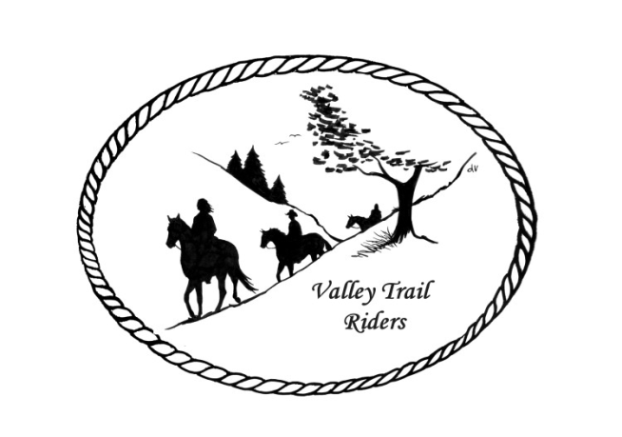 | January 2024 Newsletter

CLUB NEWS
At our November Meeting Kurtis Longenecker provided BBQ sandwiches and chips for everyone and members brought yummy sides. Thank you Kurtis!! We also held the election of officers and board of directors. Below you will see the newly elected officers. We welcomed three new members to the club; Sherry Miller, Liz and Marvin Longenecker (returning members), and Clair Lutz.
Carolyn Moehring has been our treasurer for six years and is stepping down from that position. We thanked her for her dedication and service to the club with a huge round of applause!!
The Christmas Party this year was a huge success!! Thank you to our Committee!!! We enjoyed great food provided by Eichmann’s and wonderful dancing music provided by the Just For Fun Band. The silent Auction and 50/50 raffle raised a huge amount of money and we had many guests join us for the music and dancing. The event financially self-sustained.
Please remember that Club Dues are due by January 31st. The January meeting is a good time to bring your check😊 --there is a $5 assessment fee if paid after January 31st, except for new members. DUES - Single -$15.00 & Family-$20.00 Make checks payable to Valley Trail Riders and mail to: Rose Shedd, 6744 Freeport Road, Rockton, IL 61072-9426.

At our January meeting Terry Busby will explain the additions and corrections he has made to the website and how to use our tracking system for year-end awards.
Officers:
President – Lorrie Conry (815-973-2192)
Vice President – Yvonne Comm
Secretary – Caron Paschke
Treasurer – Rose Shedd

Any questions or concerns can be directed to an officer at any time.

Club Board of Directors: Diane Feuillerat, Susan Krug, and Donna Howland

Liaisons to our local parks:

Rock Cut State Park: Terry Herbig – To report any problems at the park call 815-885-3311

Franklin Creek State Park: We need a new liaison for this park

Winnebago Forest Preserves: Debbi Hamilton & Nora Clapsaddle

Ride Committee: Chair Donna Meyer and Co-Chair Donna Howland
Club Website Manager – Terry Busby --To contact Terry, please go to the website and click on support or email support@ valleytrailriders.club.
The website address is: www.Valleytrailriders.club
To access the members-only side of the website, Click on the join button--Fill out the form --Click the Submit button. This area includes: Area to submit Blog articles, club newsletter and meeting minutes, Member contacts and Club Bylaws. If you have not done so yet, please go on our website and create your member log in. Terry will approve your access to the “Members Only” section once he verifies your paid membership. When you are approved, you will be set up with your own club email address that links to your personal email address.

Facebook Page Administrator- Kurtis Longenecker -- Please forward anything you want posted, such as pictures or events on our page to Kurtis at k_longenecker@valleytrailriders.club

Valley Trail Riders Apparel-You can purchase hats, t-shirts, sweatshirts, etc…by contacting Rose Shedd at 815-979-5998 - Rose also brings items for sale, to our club meetings😊

Calendar

- January 9, 2024 – Club meeting at the Cook House at Lockwood Park -6:30 p.m.
(Bring an appetizer or finger food to share if you like)

- January 20, 2024 – Game Day at Comm’s home- Starts at noon – Snacks, finger foods, and drinks will be provided. You may bring a snack to share or your favorite drink if you like. Yvonne has games planned. If you want to gamble, bring a roll of quarters.
663 Hampshire Drive, Hampshire
Please RSVP to Yvonne at 847-409-8678

- February 13, 2024 Club meeting at the Cook House at Lockwood Park -6:30 p.m.
(Bring a sweet treat to share if you like)

- February 17, 2024 – Game Day at the Busby/Conry Home- Starts at noon – You may bring a snack to share or your favorite drink if you like. Lorrie will make chili. We will have card games and board games. 10538 N. Pecatonica Road, Leaf River
Please RSVP to Lorrie at 815-973-2192

- March12, 2024 Club meeting at the Cook House at Lockwood Park -6:30 p.m.
Pizza Night- we will order when the meeting starts- eat afterwards

