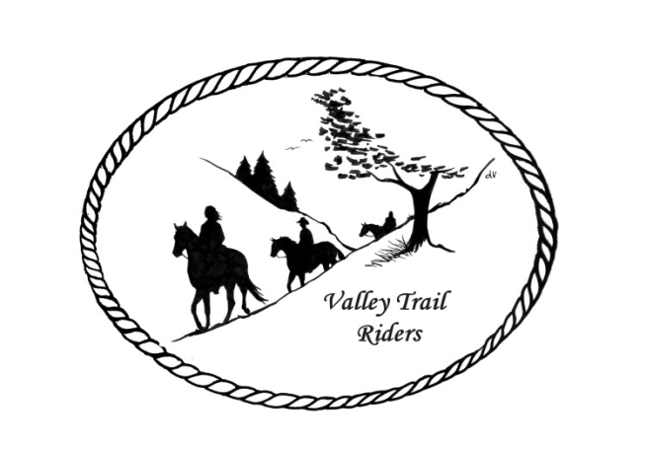 | December 2023 Newsletter

CLUB NEWS

At our November meeting we enjoyed a yummy BBQ sandwich prepared by Kurtis Longenecker and delicious sides brought by members. We also held our election of officers. The following were elected:
Board of Directors - Diane Feuillerat, Donna Howland, and Susan Krug
Officers - President - Lorrie Conry, Vice-President - Yvonne Comm, Secretary - Caron Paschke, and Treasurer - Rose Shedd. They will take over at our January meeting.
Our Christmas party is on December 9th. Please remember to bring a check or cash for the silent auction.
We will not be having a regular meeting this month. At the January meeting we will be discussing our yearly charitable donations and any future plans for forming a social committee in addition to our ride committee.
Yearly dues are due before January 31st. If you are attending the Christmas party that is a good time to bring your check😊
Officers:
President – Lorrie Conry (815-973-2192)
Vice President – Terry Busby
Secretary – Caron Paschke
Treasurer – Carolyn Moehring

Any questions or concerns can be directed to an officer at any time.

Club Board of Directors: Linda Thomas, Susan Krug, and Rose Shedd

Liaisons to our local parks:

Rock Cut State Park: Terry Herbig – To report any problems at the park call 815-885-3311

Franklin Creek State Park: We need a new liaison for this park

Winnebago Forest Preserves: Debbi Hamilton and Nora Clapsaddle

Ride Committee: Chair Donna Meyer and Co-Chair Donna Howland
Club Website Manager – Terry Busby --To contact Terry, please go to the website and click on support or email support@ valleytrailriders.club.
The website address is: www.Valleytrailriders.club
To access the members-only side of the website, Click on the join button--Fill out the form --Click the Submit button. This area includes: Area to submit Blog articles, club newsletter and meeting minutes, Member contacts and Club Bylaws. If you have not done so yet, please go on our website and create your member log in. Terry will approve your access to the “Members Only” section once he verifies your paid membership. When you are approved, you will be set up with your own club email address that links to your personal email address.

Facebook Page Administrator – Kurtis Longenecker -- Please forward anything you want posted, such as pictures or events on our page to Kurtis at k_longenecker@valleytrailriders.club

Valley Trail Riders Apparel: You can purchase hats, t-shirts, sweatshirts, etc…by contacting Rose Shedd at 815-979-5998 - Rose also brings items for sale, to our club meetings😊

DUES - Single -$15.00 & Family-$20.00 Due by January 31st.

Make checks payable to Valley Trail Riders and mail to: Carolyn Moehring, 3881 Page Rd, Rockford, 61101

Calendar

- December 9 --Christmas Party at Jarrett Prairie Center in Byron, IL- Cocktail hour beginning at 5:30pm, with Dinner and dancing to follow.

- January 20, 2024 – Game Day at Comm’s home- Starts at noon – Snacks, finger foods, and drinks will be provided. You may bring a snack to share or your favorite drink if you like. Yvonne has games planned. If you want to gamble, bring a roll of quarters.

- February 17, 2024 – Game Day at the Busby/Conry Home- Starts at noon – bring an appetizer to share. Lorrie will make chili. We will have card games and board games.

