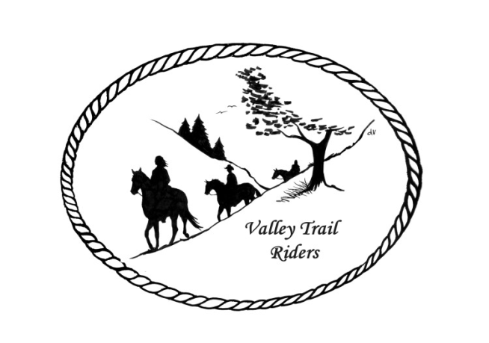 | November 2023 Newsletter

CLUB NEWS
Our event in October was the Chili Dump Ride at Rock Cut State Park, which was hosted by: Donna H Donna M and Cindy E. Members brought prepared chili based on their own recipes and all chili was placed in one roaster for everyone to enjoy along with sides and desserts. The shake and wiggle game was played with Liz Longenecker coming in first place and Kurtis Longenecker with second place. During the weekend, members came to the park for day rides, and members also camped for the weekend enjoying social time around the campfire in the evening. An obstacle course was set up by Lori Edwards, Cindy Edwards and Donna Howland for riders and their horses to enjoy.
It’s time to get your sheets filled out for our year-end awards!! There is a note from the committee below.
Christmas Party reservations need to be in by November 17th. We need a head count for food, so if your reservation is not going to possibly reach Carolyn in time, please contact Lorrie at the number below with your numbers. Send reservations (who are coming) and a check for $25 per person to our Treasurer: Carolyn Moehring, 3881 Page Rd, Rockford, 61101. You are allowed to invite a plus one guest. (Christmas party flyer details attached) Remember that the dance is open to the public – tell your family and friends!!!
Any questions or concerns can be directed to an officer at any time.
Officers:
President – Lorrie Conry (815-973-2192)
Vice President – Terry Busby
Secretary – Caron Paschke
Treasurer – Carolyn Moehring

Club Board of Directors: Linda Thomas, Susan Krug, and Rose Shedd

Liaisons to our local parks:

Rock Cut State Park: Terry Herbig – To report any problems at the park call 815-885-3311

Franklin Creek State Park: We need a new liaison for this park

Winnebago Forest Preserves: Debbi Hamilton

Ride Committee: Chair Donna Meyer and Co-Chair Donna Howland
Welcome to Year End 2023 Club Awards!
In order to compile points and prepare awards to be presented at the December Banquet, Hours ridden and points summary sheets are due to Donna Howland at Copperandkatie1@gmail.com by November 15th. You can turn in your completed forms at the meeting on November 14th. Forms are attached.
-For those of you that are used to spreadsheets, there is one excel spreadsheet attached with 3 tabs with the forms for you to complete and send to Donna.
-For those of you used to printing off forms and filling them in manually, print the attached PDF forms and send to Donna. (If you are going to snail mail the completed forms, contact Donna for mailing address)
-Blank forms will also be available at the November 14th meeting or give Donna a call at 815-222-7345 for assistance. Thank you.

Club Website Manager – Terry Busby --To contact Terry, please go to the website and click on support or email support@ valleytrailriders.club.
The website address is: www.Valleytrailriders.club
To access the members-only side of the website, Click on the join button--Fill out the form --Click the Submit button. This area includes: Area to submit Blog articles, club newsletter and meeting minutes, Member contacts and Club Bylaws. If you have not done so yet, please go on our website and create your member log in. Terry will approve your access to the “Members Only” section once he verifies your paid membership. When you are approved, you will be set up with your own club email address that links to your personal email address.

Facebook Page Administrator – Kurtis Longenecker -- Please forward anything you want posted, such as pictures or events on our page to Kurtis at k_longenecker@valleytrailriders.club

Valley Trail Riders Apparel: You can purchase hats, t-shirts, sweatshirts, etc…by contacting Rose Shedd at 815-979-5998 - Rose also brings items for sale, to our club meetings😊

DUES - Single -$15.00 & Family-$20.00 Make checks payable to Valley Trail Riders and mail to: Carolyn Moehring, 3881 Page Rd, Rockford, 61101

Calendar

- November 14 -- Club meeting at the Cook House at Lockwood Park -6:30 p.m.
Main order of business is Election of officers and suggestions for our annual charitable donations. Kurtis Longenecker is providing barbeque sandwiches and chips; you can bring something else to share if you like.

- December 9 --Christmas Party at Jarrett Prairie Center in Byron, IL- Cocktail hour beginning at 5:30pm, with Dinner and dancing to follow. Detailed flyer attached!!

