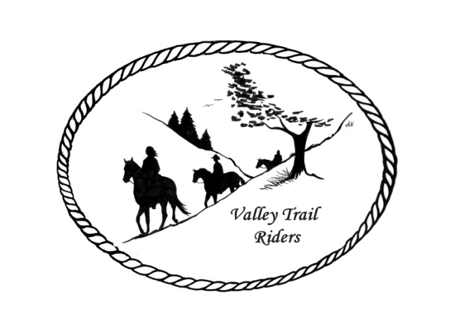 | October 2023 Newsletter

CLUB NEWS
Our event in September was our famous Steak Fry at Rock Cut State Park which was hosted by Terry Herbig and Carolyn Moehring. A huge shout out to the gals for putting on a great event and thanks to Matt Wheeler and Don Herbig for grilling the delicious steaks!! Members and friends enjoyed a fun filled weekend of camping, campfires and riding. We have one more riding and camping event this year coming up soon at Rock Cut. Our annual Chili Dump!! Check the calendar, website and Facebook for details.
Just a reminder to track your hours riding on your horse and also check out all the categories to earn points for our year-end awards!! I will attach the categories and points sheet to this newsletter again.
I will also attach to this newsletter a recap of the year’s events from our ride committee. Lots of fun was had by all!!
You can start getting your Christmas Party reservations in at any time now. Please send them to our Treasurer Carolyn at the address below. (Christmas party details attached)
Any questions or concerns can be directed to an officer at any time.
Officers:
President – Lorrie Conry (815-973-2192)
Vice President – Terry Busby
Secretary – Caron Paschke
Treasurer – Carolyn Moehring

Club Board of Directors: Linda Thomas, Susan Krug, and Rose Shedd

Liaisons to our local parks:

Rock Cut State Park: Terry Herbig – To report any problems at the park call 815-885-3311

Franklin Creek State Park: We need a new liaison for this park

Winnebago Forest Preserves: Debbi Hamilton

Ride Committee: Chair Donna Meyer and Co-Chair Donna Howland
Club Website Manager – Terry Busby --To contact Terry, please go to the website and click on support or email support@ valleytrailriders.club.
The website address is: www.Valleytrailriders.club
To access the members-only side of the website, Click on the join button--Fill out the form --Click the Submit button. This area includes: Area to submit Blog articles, club newsletter and meeting minutes, Member contacts and Club Bylaws. If you have not done so yet, please go on our website and create your member log in. Terry will approve your access to the “Members Only” section once he verifies your paid membership. When you are approved, you will be set up with your own club email address that links to your personal email address.

Facebook Page Administrator – Kurtis Longenecker -- Please forward anything you want posted, such as pictures or events on our page to Kurtis at k_longenecker@valleytrailriders.club

Valley Trail Riders Apparel: You can purchase hats, t-shirts, sweatshirts, etc…by contacting Rose Shedd at 815-979-5998 - Rose also brings items for sale, to our club meetings😊

DUES - Single -$15.00 & Family-$20.00 Make checks payable to Valley Trail Riders and mail to: Carolyn Moehring, 3881 Page Rd, Rockford, 61101

Calendar

- October 6-8 Chili Dump at Rock Cut
Hosted by: Donna H Donna M and Cindy E
On Saturday night the Club is providing cornbread and table service. Participants bring chili to dump in the pot, beverages and chili fixins, sides or dessert
7:00 p.m. we can do some games, then 8:00 p.m. would be campfire if not earlier.
Breakfast will be at 8:00 a.m. on Sunday morning at the shelter. Rides throughout the weekend are organized by members as you see fit.

- November 14 -- Club meeting at the Cook House at Lockwood Park -6:30 p.m.
Main order of business is Election of officers and suggestions for our annual charitable donations. Kurtis is providing barbeque sandwiches and chips; you can bring something else to share if you like.

- December 9 --Christmas Party at Jarrett Prairie Center in Byron, IL- Cocktail hour beginning at 5:30pm, with Dinner and dancing to follow.

