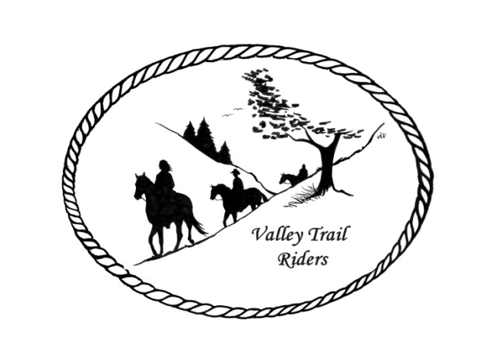 | September 2023 Newsletter

CLUB NEWS
Our event this month was at the Shedd farm on August 5 & 6 – It was a member’s only event featuring Chip Mesnar. Chip played songs on his guitar and sang while we enjoyed a dinner of pulled pork and brats with all the fixings by the Camp Fire. There were rides on Saturday and Sunday through beautiful trails on the Shedd property. Thank you to the Mark and Rose Shedd for a wonderful weekend!!
Just a reminder to track your hours riding on your horse and also check out all the categories to earn points for our year-end awards!!
Any questions or concerns can be directed to an officer at any time.
Officers:
President – Lorrie Conry (815-973-2192)
Vice President – Terry Busby
Secretary – Caron Paschke
Treasurer – Carolyn Moehring

Club Board of Directors: Linda Thomas, Susan Krug, and Rose Shedd

Liaisons to our local parks:

Rock Cut State Park: Terry Herbig – To report any problems at the park call 815-885-3311

Franklin Creek State Park: Rosemarie Farmer

Winnebago Forest Preserves: Debbi Hamilton

Ride Committee: Chair Donna Meyer and Co-Chair Donna Howland
Club Website Manager – Terry Busby --To contact Terry, please go to the website and click on support or email support@ valleytrailriders.club.
The website address is: www.Valleytrailriders.club
To access the members-only side of the website, Click on the join button--Fill out the form --Click the Submit button. This area includes: Area to submit Blog articles, club newsletter and meeting minutes, Member contacts and Club Bylaws. If you have not done so yet, please go on our website and create your member log in. Terry will approve your access to the “Members Only” section once he verifies your paid membership. When you are approved, you will be set up with your own club email address that links to your personal email address.

Facebook Page Administrator – Kurtis Longenecker -- Please forward anything you want posted, such as pictures or events on our page to Kurtis at k_longenecker@valleytrailriders.club

Valley Trail Riders Apparel: You can purchase hats, t-shirts, sweatshirts, etc…by contacting Rose Shedd at 815-979-5998 - Rose also brings items for sale, to our club meetings😊

DUES - Single -$15.00 & Family-$20.00 Make checks payable to Valley Trail Riders and mail to: Carolyn Moehring, 3881 Page Rd, Rockford, 61101

Calendar

- September 16 --Ride and Steak Dinner at Rock Cut Equestrian area
Hosted by: Terry Herbig
Steak fry will be at 5:00 p.m. with a club meeting to follow. Join us for a New York strip steak and all the fixings. Bring your own drink. Table service is all provided by the club. Cost is $20 for a club member, $25 for a guest. You must have a reservation. Please call or text Terry at 815-289-9833. Please do not respond on Facebook or website as those reservations could be missed. Reservations are due by Monday September 11th. Riding throughout the weekend will be on your own.

- October 6-8 Chili Dump at Rock Cut
Hosted by: Donna H Donna M and Cindy E

- November 14 – Club meeting at the Cook House at Lockwood Park -6:30 p.m.
Main order of business is Election of officers

- Christmas Party at Jarrett Prairie Center in Byron, IL- Cocktail hour beginning at 5:30pm, with Dinner and dancing to follow. More details will be provided in a flyer on the event attached to this newsletter.

