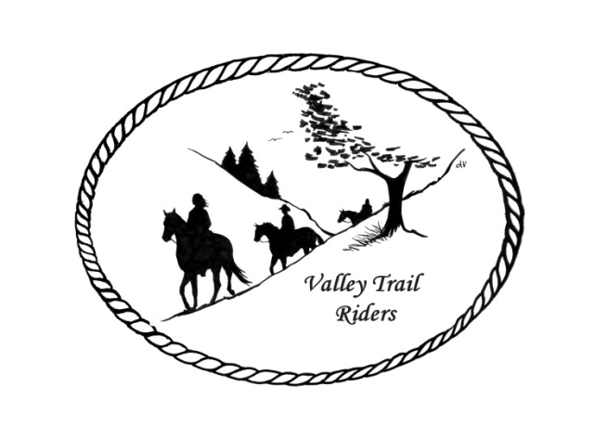 | August 2023 Newsletter

CLUB NEWS
The Christmas in July ride was hosted by Donna Howland and Donna Meyer. We enjoyed a great Mexican meal and fun White Elephant “Horsey” gift exchange on Saturday and Group breakfast Sunday morning. Lots of trail rides went out throughout the weekend and a fabulous group campfire on Saturday night. Thanks to the Donna’s!!! Our next club ride and meeting will be at the Shedd farm August 5 & 6--Details on the website.
Just a reminder to track your hours riding on your horse and also check out all the categories to earn points for our year-end awards!!
Any questions or concerns can be directed to an officer at any time.
Officers:
President – Lorrie Conry (815-973-2192)
Vice President – Terry Busby
Secretary – Caron Paschke
Treasurer – Carolyn Moehring

Club Board of Directors: Linda Thomas, Susan Krug, and Rose Shedd

Liaisons to our local parks:

Rock Cut State Park: Terry Herbig – To report any problems at the park call 815-885-3311

Franklin Creek State Park: Rosemarie Farmer

Winnebago Forest Preserves: Debbi Hamilton

Ride Committee: Chair Donna Meyer and Co-Chair Donna Howland
Club Website Manager – Terry Busby --To contact Terry, please go to the website and click on support or email support@ valleytrailriders.club.
The website address is: www.Valleytrailriders.club
To access the members-only side of the website, Click on the join button--Fill out the form --Click the Submit button. This area includes: Area to submit Blog articles, club newsletter and meeting minutes, Member contacts and Club Bylaws. If you have not done so yet, please go on our website and create your member log in. Terry will approve your access to the “Members Only” section once he verifies your paid membership. When you are approved, you will be set up with your own club email address that links to your personal email address.

Facebook Page Administrator – Kurtis Longenecker -- Please forward anything you want posted, such as pictures or events on our page to Kurtis at k_longenecker@valleytrailriders.club

Valley Trail Riders Apparel: You can purchase hats, t-shirts, sweatshirts, etc…by contacting Rose Shedd at 815-979-5998 - Rose also brings items for sale, to our club meetings😊

DUES - Single -$15.00 & Family-$20.00 Make checks payable to Valley Trail Riders and mail to: Carolyn Moehring, 3881 Page Rd, Rockford, 61101

Calendar

- August 5-6 Members only Camping and poker run at Rose & Mark Shedds’s Farm
RSVP by July 30th
Check in Saturday Morning 8:30am
Ride 1:00pm
Meeting 5:30pm
Dinner 6:00pm (Provided by the Club and the Shedd’s)
CampFire after dinner with Chip Mesnar playing campfire songs on his guitar
Sunday Breakfast 8:00am ish
Ride 9:30am – 10:00am ish
Horse Riders need to sign waiver
- September 16 Ride and Steak Dinner at Rock Cut- Hosted by: Terry Herbig
Club Mtg on Saturday night

- October 6-8 Chili Dump at Rock Cut
Hosted by: Donna H Donna M and Cindy E

