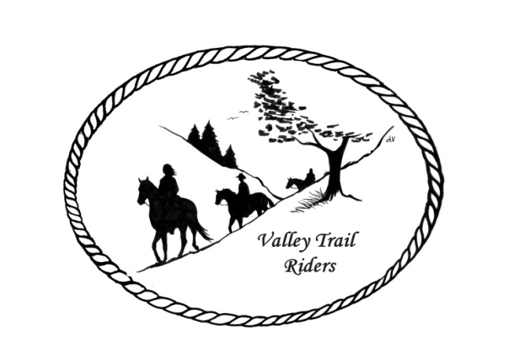 | July 2023 Newsletter

CLUB NEWS
The Poker run at Franklin Creek was hosted by Linda Odom and Pam Lee. We had lots of fun with great prizes and delicious food. Thanks to Linda and Pam. One of our guests, Melinda Milam won the poker run. Dr. Sarah Pearson presented lots of great information on equine dental health. She brought some trivia questions on equine teeth and gave prizes for winners. Caron Paschke won the equine trivia game. Huge thanks to Dr. Sarah!!! We decided not to hold a club meeting.
We welcome three new VTR members this month – Betsy Scaletta, Frankie Benson, and Sandra Gramkowski!!
The Christmas Party committee has been collecting lots of great items for our silent auction, but we still need more – please help them out by contacting vendors and businesses to try secure donations for the silent auction. You can contact any committee member and we will make arrangements to get the items from you--Rose Shedd, Susan Krug, Caron Paschke, Yvonne Comm, Lorrie Conry and Debbi Hamilton.
Just a reminder to track your hours riding on your horse and also check out all the categories to earn points for our year-end awards!!
Any questions or concerns can be directed to an officer at any time.
Officers:
President – Lorrie Conry (815-973-2192)
Vice President – Terry Busby
Secretary – Caron Paschke
Treasurer – Carolyn Moehring

Club Board of Directors: Linda Thomas, Susan Krug, and Rose Shedd

Liaisons to our local parks:

Rock Cut State Park: Terry Herbig – To report any problems at the park call 815-885-3311

Franklin Creek State Park: Rosemarie Farmer

Winnebago Forest Preserves: Debbi Hamilton

Ride Committee: Chair Donna Meyer and Co-Chair Donna Howland
Club Website Manager – Terry Busby --To contact Terry, please go to the website and click on support or email support@ valleytrailriders.club.
The website address is: www.Valleytrailriders.club
To access the members-only side of the website, Click on the join button--Fill out the form --Click the Submit button. This area includes: Area to submit Blog articles, club newsletter and meeting minutes, Member contacts and Club Bylaws. If you have not done so yet, please go on our website and create your member log in. Terry will approve your access to the “Members Only” section once he verifies your paid membership. When you are approved, you will be set up with your own club email address that links to your personal email address.

Facebook Page Administrator – Kurtis Longenecker -- Please forward anything you want posted, such as pictures or events on our page to Kurtis at k_longenecker@valleytrailriders.club

Valley Trail Riders Apparel: You can purchase hats, t-shirts, sweatshirts, etc…by contacting Rose Shedd at 815-979-5998 - Rose also brings items for sale, to our club meetings😊

DUES - Single -$15.00 & Family-$20.00 Make checks payable to Valley Trail Riders and mail to: Carolyn Moehring, 3881 Page Rd, Rockford, 61101

Calendar

- July 14-16 Christmas in July @ Rock Cut Equestrian Campground
- Hosted by: Donna Howland and Donna Meyer
Saturday
10:30 am - Group ride if interest or ride on your own
5:00 pm - Tacos – Taco meat, shells, lettuce, salsa, sour cream, and shredded cheese will be provided. Please bring a Mexican Dish, salad or dessert to share.
There will be a short Club meeting after dinner.
7:00 pm – “Horsey” White Elephant Gift to share.
9:00 pm - Camp Fire
Sunday Morning
8:30 Breakfast at Pavilion
All table service will be provided – bring your own drinks
If it rains we'll be dry in the pavilion.

- August 4-6 Members only Camping and poker run at Rose & Mark Shedds’s Farm
Club Mtg on Saturday night

- September 16 Ride and Steak Dinner at Rock Cut- Hosted by: Terry Herbig
Club Mtg on Saturday night

- October 6-8 Chili Dump at Rock Cut
Hosted by: Donna H Donna M and Cindy E

