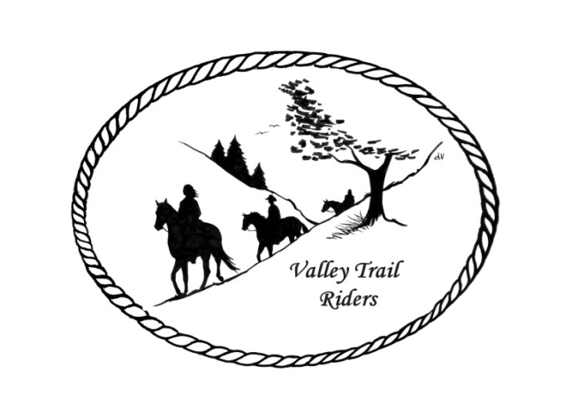 | June 2023 Newsletter

CLUB NEWS:
Our Memorial Weekend ride was lots of fun, even though many members had already made plans to ride far away. We did have two guests from Morrison join us for the Saturday ride because they saw our post on Face Book! Our Saturday night meal was delicious: Terry’s shrimp tacos with special sauce, slaw and guacamole, Shauna’s special slow cooked pork and beans with rice and of course desserts by Linda!! Join us for the Poker run in June at Franklin Creek, check the calendar for details. Also follow our Face Book page for pictures and more information about the upcoming ride.
Please help the Christmas Party committee out by contacting vendors and businesses to try secure donations for the silent auction. You can contact any committee member and we will make arrangements to get the items from you--Rose Shedd, Susan Krug, Caron Paschke, Yvonne Comm, Lorrie Conry and Debbi Hamilton.
Just a reminder to start tracking your hours on your horse and also check out all the categories to earn points for our year-end awards!!
Any questions or concerns can be directed to an officer at any time.

Officers:
President – Lorrie Conry (815-973-2192)
Vice President – Terry Busby
Secretary – Caron Paschke
Treasurer – Carolyn Moehring

Club Board of Directors: Linda Thomas, Susan Krug, and Rose Shedd

Liaisons to our local parks:

Rock Cut State Park: Terry Herbig – To report any problems at the park call 815-885-3311

Franklin Creek State Park: Rosemarie Farmer

Winnebago Forest Preserves: Debbi Hamilton

Ride Committee: Chair Donna Meyer and Co-Chair Donna Howland

Club Website Manager – Terry Busby --To contact Terry, please go to the website and click on support or email support@ valleytrailriders.club.
The website address is: www.Valleytrailriders.club
To access the members-only side of the website, Click on the join button--Fill out the form --Click the Submit button. This area includes: Area to submit Blog articles, club newsletter and meeting minutes, Member contacts and Club Bylaws. If you have not done so yet, please go on our website and create your member log in. Terry will approve your access to the “Members Only” section once he verifies your paid membership. When you are approved, you will be set up with your own club email address that links to your personal email address.

Facebook Page Administrator – Kurtis Longenecker -- Please forward anything you want posted, such as pictures or events on our page to Kurtis at k_longenecker@valleytrailriders.club

Valley Trail Riders Apparel: You can purchase hats, t-shirts, sweatshirts, etc…by contacting Rose Shedd at 815-979-5998 - Rose also brings items for sale, to our club meetings😊

DUES - Single -$15.00 Family-$20.00 Make checks payable to Valley Trail Riders and mail to: Carolyn Moehring, 3881 Page Rd, Rockford, 61101

Calendar

- June 23-25 Franklin Creek Poker Run - Host: Pam and Linda- Club Mtg on Saturday night with Guest Speaker Dr. Sara Pearson, DVM on Equine Dental Care and other equine care topics

- July 14-16 Rock Cut- Christmas in July Host: Donna and Donna- Club Mtg on Saturday night

- August 4-6 Members only Camping at Rose & Mark Shedds’s- Farm poker-run- Club Mtg on Saturday night

- September 16 Ride and Steak Dinner at Rock Cut- Host: Terry Herbig - Club Mtg on Saturday night

- October 6-8 Chili Dump at Rock Cut - Host: Donna H Donna M and Cindy E

