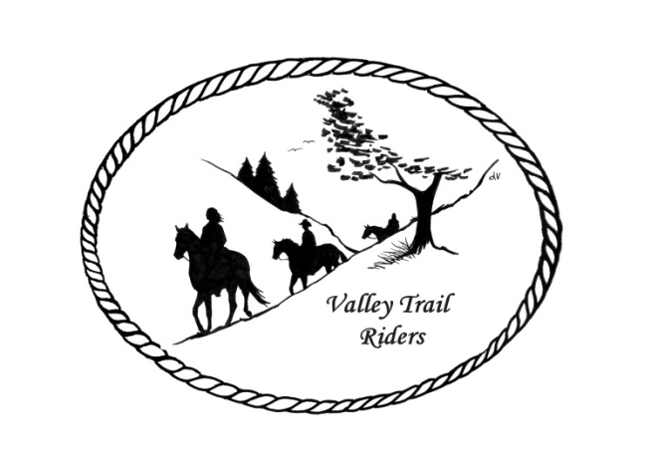 | May 2023 Newsletter

CLUB NEWS:
Our April meeting began with a potluck dinner and it was followed with a presentation by member Yvonne Com on Daily Energy Routine and self-care. Dr. Sara Pearson, DVM will be speaking at a future summer meeting on dental and other veterinary care for horses; the date to be determined. Our next meeting will be the last one at the cookhouse for the summer. Our next few months’ meetings will be in conjunction with rides.
We welcomed new member Chelsae Whitmire to our club. Chelsae brought some delicious chocolate treats that she made for us. She owns and operates ABC Confectionz Chocolate Desserts.
Just a reminder--Please help the Christmas Party committee out by contacting vendors and businesses to try secure donations for the silent auction. You can contact any committee member and we will make arrangements to get the items from you--Rose Shedd, Susan Krug, Caron Paschke, Yvonne Comm, Lorrie Conry and Debbi Hamilton.
Just a reminder to start tracking your hours on your horse and also check out all the categories to earn points for our year-end awards!! This is posted on our website.
Any questions or concerns can be directed to an officer at any time. If you would like to speak at a meeting or bring a guest speaker, please clear this through the officers ahead of time.

Officers:
President – Lorrie Conry (815-973-2192)
Vice President – Terry Busby
Secretary – Caron Paschke
Treasurer – Carolyn Moehring

Club Board of Directors: Linda Thomas, Susan Krug, and Rose Shedd

Liaisons to our local parks:

Rock Cut State Park: Terry Herbig – To report any problems at the park call 815-885-3311

Franklin Creek State Park: Rosemarie Farmer

Winnebago Forest Preserves: Debbi Hamilton

Ride Committee: Chair Donna Meyer and Co-Chair Donna Howland

Club Website Manager – Terry Busby --To contact Terry, please go to the website and click on support or email support@ valleytrailriders.club.
The website address is: www.Valleytrailriders.club
To access the members-only side of the website, Click on the join button--Fill out the form --Click the Submit button. This area includes: Area to submit Blog articles, club newsletter and meeting minutes, Member contacts and Club Bylaws. If you have not done so yet, please go on our website and create your member log in. Terry will approve your access to the “Members Only” section once he verifies your paid membership. When you are approved, you will be set up with your own club email address that links to your personal email address.

Facebook Page Administrator – Kurtis Longenecker Please forward anything you want posted, such as pictures or events on our page to Kurtis at k_longenecker@valleytrailriders.club

Valley Trail Riders Apparel: You can purchase hats, t-shirts, sweatshirts, etc…by contacting Rose Shedd at 815-979-5998 - Rose also brings items for sale, to our club meetings😊

DUES - Single -$15.00 Family-$20.00 Make checks payable to Valley Trail Riders and mail to: Carolyn Moehring, 3881 Page Rd, Rockford, 61101

Calendar

- May 9, 2023 Club Meeting at the Lockwood Cookhouse @6:30pm (bring a snack to share if you like)

- May 26-29 Franklin Creek Memorial Day Ride – Hosts Terry Busby and Lorrie Conry

- June 23-25 Franklin Creek Poker Run - Host: Pam and Linda- Club Mtg on Saturday night

- July 14-16 Rock Cut Christmas in July Host: Donna and Donna- Club Mtg on Saturday night

- August 4-6 Members only Camping at Rose & Mark Shedds’s- Farm poker-run- Club Mtg on Saturday night

- September 16 Ride and Steak Dinner at Rock Cut- Host: Terry Herbig - Club Mtg on Saturday night

- October 6-8 Chili Dump at Rock Cut - Host: Donna H Donna M and Cindy E

Valley Trail Riders Year-End Awards which will be presented at the year-end Banquet
Final Awards Presentation is at Discretion of Board of Directors.
Each category awarded to first and second place---Ties managed by Awards Committee
Points calculated 12 month period November 1 to October 31
- Most Hours in the Saddle or Driving a cart
Round to the nearest 15 minutes
Hours recorded from November 1 to October 31
Submit totals each year to Awards Committee by November 15th
Recording form supplied by the Committee
- Most Hours in the Saddle or Driving a cart at VTR Hosted Events
Round to the nearest 15 minutes
Hours recorded from November 1 to October 31
Submit totals each year to Awards Committee by November 15th
Recording form supplied by the Committee
- Most Active Event Organizer/Committee Member/Board Member
5 points for Annual Board of Directors membership
5 points for Annual Committee Membership
3 points for Ad Hoc (temporary as needed) Committee
3 points for each posted Event organized as Chair or CoChair
Recording Form provided by Committee
- New Member Recruitment
1 point for each individual paid new membership
5 points for each new family paid membership
Recording Secretary reports
- Website Blog Activity
5 Points for each posted Blog
- Member of the Year
High point from above award categories

