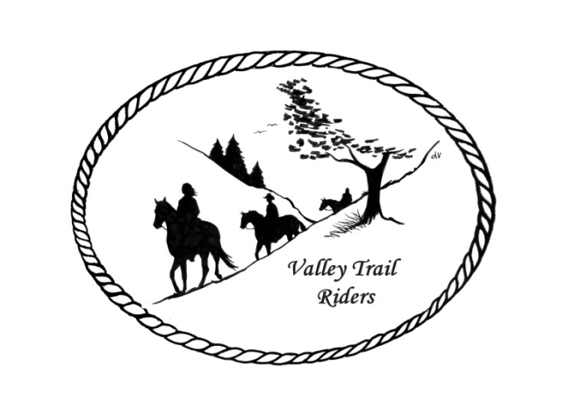 | April 2023 Newsletter

CLUB NEWS:
Our March meeting began with a presentation by Chiropractor, Dr. Bonnie Harder. She is an animal and human chiropractor. It was very informational and if you would like her contact information it is on the website or you may contact Lorrie Conry. We enjoyed a pizza party after her presentation before our meeting.
For our next meeting in April we will have a guest speaker at 6:30 pm. Our very own member Yvonne Comm, will speak on Daily Energy Renewal for our bodies. Dress comfortably, as she will go through a routine with us😊
We welcomed new members to our club at the March meeting: Pam Carter, Barrett and Grace Manning, Ellen Inman, Diane Croom and returning members Tyanne and Glenn Wallin.
Just a reminder--Please help the Christmas Party committee out by contacting vendors and businesses to try secure donations for the silent auction. You can contact any committee member and we will make arrangements to get the items from you--Rose Shedd, Susan Krug, Caron Paschke, Yvonne Comm, Lorrie Conry and Debbi Hamilton.
It is with great sadness to report that we lost two of our members last month. Barry Fagerstrom and Mary Allen passed away. Please keep their families in your thoughts and prayers. Condolences have been sent from our club.
Game day was a lot of fun and Lorrie and Terry will host another one in the future. The bowling party was cancelled due to lack of participation.
Any questions or concerns can be directed to an officer at any time. If you would like to speak at a meeting or bring a guest speaker, please clear this through the officers ahead of time.

Officers:
President – Lorrie Conry (815-973-2192)
Vice President – Terry Busby
Secretary – Caron Paschke
Treasurer – Carolyn Moehring

Club Board of Directors: Linda Thomas, Susan Krug, and Rose Shedd

Liaisons to our local parks:

Rock Cut State Park: Terry Herbig

Franklin Creek State Park: Rosemarie Farmer

Winnebago Forest Preserves: Debbi Hamilton

Ride Committee: Chair Donna Meyer and Co-Chair Donna Howland
Scheduled rides: See Calendar
Club Website Manager – Terry Busby --To contact Terry, please go to the website and click on support or email support@ valleytrailriders.club.
The website address is: www.Valleytrailriders.club
To access the members-only side of the website, Click on the join button--Fill out the form --Click the Submit button. This area includes: Area to submit Blog articles, club newsletter and meeting minutes, Member contacts and Club Bylaws. If you have not done so yet, please go on our website and create your member log in. Terry will approve your access to the “Members Only” section once he verifies your paid membership. We plan to relay most of our club information and news through the website. When you are approved, you will also be set up with your own club email address that links to your personal email address.

Facebook Page Administrator – Kurtis Longenecker Please forward anything you want posted, such as pictures or events on our page to Kurtis at k_longenecker@valleytrailriders.club

Valley Trail Riders Apparel: You can purchase hats, t-shirts, sweatshirts, etc…by contacting Rose Shedd at 815-979-5998 - Rose also brings items for sale, to our club meetings😊

DUES - Single -$15.00 Family-$20.00 Make checks payable to Valley Trail Riders and mail to: Carolyn Moehring, 3881 Page Rd, Rockford, 61101

For your information:
Rides scheduled at Franklin Creek State Park
by Rock River Trail and Horsemen’s Association
June 10-11 – Potluck at 6pm
July 15-16
August 12-13
September 16 – Fun Show on September 17 at 10am

Calendar

- April 11, 2023 Club Meeting at the Lockwood Cookhouse @6:30pm (Potluck dinner- before the meeting, which will start around 7pm) Yvonne Comm will be our guest speaker on Daily Energy renewal

- May 9, 2023 Club Meeting at the Lockwood Cookhouse @6:30pm (bring a snack to share if you like)

- May 26-29 Franklin Creek Memorial Day Ride – Hosts Terry Busby and Lorrie Conry

- June 23-25 Franklin Creek Poker Run - Host: Pam and Linda- Club Mtg on Saturday night

- July 14-16 Rock Cut Christmas in July Host: Donna and Donna- Club Mtg on Saturday night

- August 4-6 Members only Camping at Rose & Mark Shedds’s- Farm poker-run- Club Mtg on Saturday night

- September 16 Ride and Steak Dinner at Rock Cut- Host: Terry Herbig - Club Mtg on Saturday night

- October 6-8 Chili Dump at Rock Cut - Host: Donna H Donna M and Cindy E

Valley Trail Riders Year-End Awards which will be presented at the year-end Banquet
Final Awards Presentation is at Discretion of Board of Directors.
Each category awarded to first and second place---Ties managed by Awards Committee
Points calculated 12 month period November 1 to October 31
- Most Hours in the Saddle or Driving a cart
Round to the nearest 15 minutes
Hours recorded from November 1 to October 31
Submit totals each year to Awards Committee by November 15th
Recording form supplied by the Committee
- Most Hours in the Saddle or Driving a cart at VTR Hosted Events
Round to the nearest 15 minutes
Hours recorded from November 1 to October 31
Submit totals each year to Awards Committee by November 15th
Recording form supplied by the Committee
- Most Active Event Organizer/Committee Member/Board Member
5 points for Annual Board of Directors membership
5 points for Annual Committee Membership
3 points for Ad Hoc (temporary as needed) Committee
3 points for each posted Event organized as Chair or CoChair
Recording Form provided by Committee
- New Member Recruitment
1 point for each individual paid new membership
5 points for each new family paid membership
Recording Secretary reports
- Website Blog Activity
5 Points for each posted Blog
- Member of the Year
High point from above award categories

