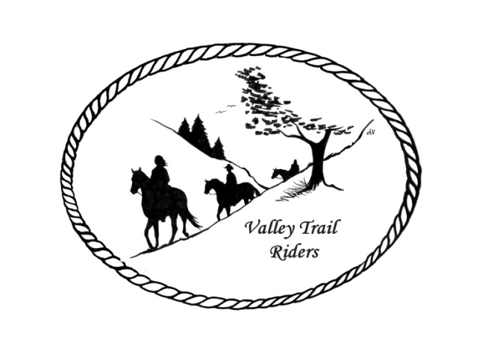 | March 2023 Newsletter

CLUB NEWS:
Our February meeting began with sweet treats and social time. For our next meeting in March we will have a guest speaker at 6:30 pm. Dr. Bonnie Harder will speak on the benefits of chiropractic for horses. We will order pizza for after the meeting, complimentary of the club.
Christmas party plans are coming along nicely. The party will be on December 9, 2023 at the Byron Prairie Jarrett Center in the lower level. Cocktail hour begins at 5:30; Dinner at 6pm; Eickman’s will be serving the meal and do cleanup after the meal; Live band “Just 4 Fun” will begin at 8pm and ending at 11pm. You may invite friends, family and other horse enthusiasts to join us at 8pm for the band with an admission of $10 per person. The cost for the banquet including meal and entertainment will be $25 per person for members. There will be a cash bar from 5:30 – 10pm. We will have a 50/50 drawing and Silent Auction. Please help the committee out by contacting vendors and businesses to try secure donations for the auction. You can contact any committee member and we will make arrangements to get the items from you--Rose Shedd, Susan Krug, Caron Paschke, Yvonne Comm, Lorrie Conry and Debbi Hamilton.
Any questions or concerns can be directed to an officer at any time. If you would like to speak at a meeting or bring a guest speaker, please clear this through the officers ahead of time.

Officers:
President – Lorrie Conry (815-973-2192)
Vice President – Terry Busby
Secretary – Caron Paschke
Treasurer – Carolyn Moehring

Club Board of Directors: Linda Thomas, Susan Krug, and Rose Shedd

Liaisons to our local parks:

Rock Cut State Park: Terry Herbig
Franklin Creek State Park: Rosemarie Farmer
Winnebago Forest Preserves: Debbi Hamilton
- Board Meeting Dates for the Forest Preserves: March 15, April 19, May 17, June 21, July19, August 16, September 20, October 25, November 15, and December 20-anyone is welcome to attend.
- Anyone wishing to speak at a board meeting must submit a request in writing by noon on the day of the meeting. Request must include name, address and subject matter. The meeting is allowed a maximum of 7 speakers, with each speaker being allowed a maximum of 3 minutes.

Ride Committee: Chair Donna Meyer
Scheduled rides:
May (possibly 3rd weekend)- Rock Cut Clean-up day -date to be determined by Kurtis
June 23-25 Franklin Creek Poker Run - Host: Pam and Linda- Club Mtg on Saturday night
July 14-16 Rock Cut Christmas in July Host: Donna and Donna- Club Mtg on Saturday night
August 4-6 Members only Camping at Rose & Mark Shedds’s- Farm poker-run- Club Mtg will be on Saturday night after dinner
September Ride and Steak Dinner- Host: Terry Herbig - date to be determined- Club Mtg will be on Saturday night after dinner
October 6-8 Chili Dump at Rock Cut - Host: Donna H Donna M and Cindy E
Scheduled Social Events:
March 19 – Bowling–Rose Shedd hosting–RSVP to Sue Krug 815-757-2384 by March 5. Flyer for the event is on the website.
Club Website Manager – Terry Busby --To contact Terry, please go to the website and click on support or email support@ valleytrailriders.club.
The website address is: www.Valleytrailriders.club
To access the members-only side of the website, Click on the join button--Fill out the form --Click the Submit button. This area includes: Area to submit Blog articles, club newsletter and meeting minutes, Member contacts and Club Bylaws. If you have not done so yet, please go on our website and create your member log in. Terry will approve your access to the “Members Only” section once he verifies your paid membership. We plan to relay most of our club information and news through the website. When you are approved, you will also be set up with your own club email address that links to your personal email address.

Facebook Page – Kurtis Longenecker administrator. Please forward anything you want posted, such as pictures or events on our page to Kurtis at k_longenecker@valleytrailriders.club

Valley Trail Riders Apparel: You can purchase hats, t-shirts, sweatshirts, etc…by contacting Rose Shedd at 815-979-5998 - Rose also brings items for sale, to our club meetings😊

Club Dues for 2023 were due by January 31st. Single -$15.00 Family-$20.00
Dues paid after that date, are assessed a $5.00 late fee.
Make checks payable to Valley Trail Riders and mail to: Carolyn Moehring, 3881 Page Rd, Rockford, 6110. This will be the last newsletter sent to those unpaid 2022 members, until dues are paid for 2023.

Calendar

- March 14, 2023 Club Meeting at the Lockwood Cookhouse @6:30pm Special guest speaker and Pizza Night- we will order when the meeting starts- eat afterwards- club picks up the tab.

- March 19 – Bowling at Forest Hills – Rose Shedd hosting – RSVP by March 5 (Sue Krug 815-757-2384)

- April 11, 2023 Club Meeting at the Lockwood Cookhouse @6:30pm (Potluck dinner- before the meeting, which will start around 7pm)

- May 9, 2023 Club Meeting at the Lockwood Cookhouse @6:30pm (bring a snack to share if you like)

