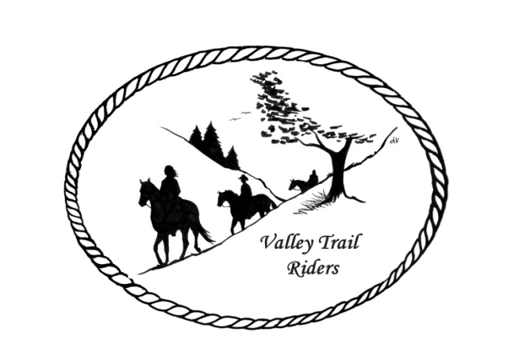 | February 2023 Newsletter

CLUB NEWS:
Our January meeting was lots of fun; we started out with appetizers and social time. For our next meeting in February we are asking everyone to bring a sweet treat, if you like. The club members at the last meeting also thought it would be fun to wear your Valley Trail Riders club apparel to the February meeting. This would also be helpful, to see all the colors and styles available if you want to order something.
There was a great discussion about the direction of our Christmas party. We talked about several options for our year end event and the club voted to have our Christmas Party at a venue where we can have a band such as the Jarrett Prairie Center in Byron. There was discussion about a silent auction, 50/50 raffle, yearend awards for competitions throughout the year (the ride committee will work on this), inviting other horse clubs, family and friends to join us for the dance, and possible choices for food. The committee formed for the event is: Yvonne Comm, Caron Paschke, Susan Krug, Debbi Hamilton, Rose Shedd and Lorrie Conry. Venue plans are in the works and Jim Wolber’s country band “Just 4 Fun” has been booked. More details to come at the February Meeting. Two other social events were planned for February and March.
Kurtis Longenecker is coordinating our spring cleanup day at the park. He is already in contact with Park personnel. Rosemarie Farmer is coordinating events with liaison at Franklin Creek State Park so we don’t overlap and members from our club can attend events at the park that other clubs are hosting and they can attend ours.
We had a new family join the club in January. Please welcome Marti and Lee Files.
Any questions or concerns can be directed to an officer. If you would like to speak at a meeting or bring a guest speaker, please clear this through the officers ahead of time.

Officers:
President – Lorrie Conry (815-973-2192)
Vice President – Terry Busby
Secretary – Caron Paschke
Treasurer – Carolyn Moehring

Club Board of Directors: Linda Thomas, Susan Krug, and Rose Shedd. (They will be meeting in February to audit the books)

Liaisons to our local parks:
Rock Cut State Park: Terry Herbig
Franklin Creek State Park: Rosemarie Farmer
Winnebago Forest Preserves: Debbi Hamilton
- Board Meeting Dates for the Forest Preserves: January 18, February 15, March 15, April 19, May 17, June 21, July19, August 16, September 20, October 25, November 15, and December 20-anyone is welcome to attend.
- Anyone wishing to speak at a board meeting must submit a request in writing by noon on the day of the meeting. Request must include name, address and subject matter. The meeting is allowed a maximum of 7 speakers, with each speaker being allowed a maximum of 3 minutes.

Ride Committee: Chair Donna Meyer
Scheduled rides:
May (possibly 3rd weekend)- Rock Cut Clean-up day -date to be determined by Kurtis
June 23-25 Franklin Creek Poker Run - Host: Pam and Linda- Club Mtg on Saturday night
July 14-16 Rock Cut Christmas in July Host: Donna and Donna- Club Mtg on Saturday night
August 4-6 Members only Camping at Rose & Mark Shedds’s- Farm poker-run- Club Mtg will be on Saturday night after dinner
September Ride and Steak Dinner- Host: Terry Herbig - date to be determined- Club Mtg will be on Saturday night after dinner
October 6-8 Chili Dump at Rock Cut - Host: Donna H Donna M and Cindy E
Scheduled Social Events:
February 25 – Game Day @Conry/Busby Home – RSVP to Lorrie 815-973-2192 by February 15
March 19 – Bowling–Rose Shedd hosting–RSVP to Sue Krug 815-757-2384 by March 5
Club Website Manager – Terry Busby --To contact Terry, please go to the website and click on support or email support@ valleytrailriders.club. The website address is: www.Valleytrailriders.club
To access members-only side of the website which includes, Member posts, Blog articles, items for sale, club newsletter, meeting minutes, etc…Click on the join button--Fill out the form --Click the Submit button

If you have not done so yet, please go on our website and create your member log in. Terry will approve your access to the “Members Only” section once he verifies your paid membership. We plan to relay most of our club information and news through the website. When you are approved, you will also be set up with your own club email address that links to your personal email address.

Facebook Page – Kurtis Longenecker will be our administrator. Please direct any ideas for posts to Kurtis.

Valley Trail Riders Apparel: You can purchase hats, t-shirts, sweatshirts, etc…by contacting Rose Shedd at 815-979-5998 - Rose also does bring items to our club meetings😊

Club Dues for 2023 need to be paid before January 31st. Single $15.00 Family $20.00 --After that date, there will be an additional $5.00 late fee for returning members.

Make checks payable to Valley Trail Riders
Mail to: Carolyn Moehring
3881 Page Rd,
Rockford, 61101

Calendar:

- February 14, 2023 Club Meeting at the Lockwood Cookhouse @6:30pm (bring a sweet treat to share if you like)

- February 25 @1pm– Game Day @Conry/Busby Home 10538 N. Pecatonica Rd. Leaf River – RSVP February 20 (815-973-2192)

- March 14, 2023 Club Meeting at the Lockwood Cookhouse @6:30pm (Pizza Night- we will order when the meeting starts- eat afterwards)

- March 19 – Bowling at Forest Hills – Rose Shedd hosting – RSVP by March 5 (Sue Krug 815-757-2384)

- April 11, 2023 Club Meeting at the Lockwood Cookhouse @6:30pm (Potluck dinner- before the meeting, which will start around 7pm)

- May 9, 2023 Club Meeting at the Lockwood Cookhouse @6:30pm (bring a snack to share if you like)

