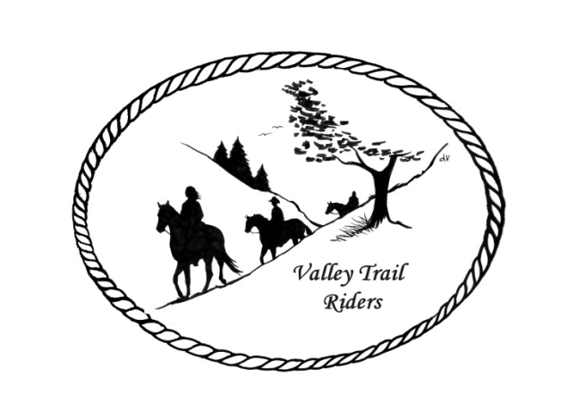 | January 2023 Newsletter

CLUB NEWS:

If you are interested in hosting an event over the winter, like a game night, bowling, or any other fun event please bring your ideas to the meeting in January. If you have ideas for our Christmas Party next year, please bring the detailed information and costs for venue (availability), food, entertainment, etc…to our January Meeting. We had talked about doing this in February, but Lorrie has done some checking around and many venues are already booking for next year. We will make a decision at our January Meeting and get a place booked.

Officers:
President – Lorrie Conry (815-973-2192)
Vice President – Terry Busby
Secretary – Caron Paschke
Treasurer – Carolyn Moehring

Club Board of Directors: Linda Thomas, Susan Krug, and Rose Shedd.

Liaisons to our local parks:
Rock Cut State Park: Terry Herbig
Franklin Creek State Park: Rosemarie Farmer
Seward Bluffs: Debbi Hamilton

Ride Committee:
May (possibly 3rd weekend)- Rock Cut Clean-up day -date to be determined by Kurtis
June 23-25 Franklin Creek Poker Run - Host: Pam and Linda- Club Mtg on Saturday night
July 14-16 Rock Cut Christmas in July Host: Donna and Donna- Club Mtg on Saturday night
August 4-6 Members only Camping at Rose & Mark Shedds’s- Farm poker-run- Club Mtg on Saturday night
September Ride and Steak Dinner- date to be determined by Terry Herbig- Club Mtg on Saturday night
October 6-8 Chili Dump at Rock Cut - Host: Donna H Donna M and Cindy E
Club Website Manager – Terry Busby --To contact Terry, please go to the website and click on support or email support@ valleytrailriders.club. The website address is: www.Valleytrailriders.club
To access members-only side of the website which includes, Member posts, Blog articles, items for sale, club newsletter, meeting minutes, etc…Click on the join button--Fill out the form --Click the Submit button

If you have not done so yet, please go on our website and create your member log in. Terry will approve your access to the Members Only section once he verifies your paid membership. We plan to relay most of our club information and news through the website. When you are approved, you will also be set up with your own club email address that links to your personal email address.

Facebook Page – Private page will close down after December 31. Working on getting the public page up and running again.

Miscellaneous info:
- Valley Trail Riders Apparel: You can purchase hats, t-shirts, sweatshirts, etc…by contacting Rose Shedd at 815-979-5998 Rose also does bring items to our club meetings😊

Club Dues for 2023 need to be paid before January 31st. Single $15.00 Family $20.00 --After that date, there will be an additional $5.00 late fee for returning members.

Make checks payable to Valley Trail Riders and mail to:
Carolyn Moehring
3881 Page Rd,
Rockford, 61101

Calendar:
- January 10, 2023 Club Meeting at the Lockwood Cookhouse @6:30pm (bring an appetizer or finger food to share if you like)

- February 14, 2023 Club Meeting at the Lockwood Cookhouse @6:30pm (bring a sweet treat to share if you like)

- March 14, 2023 Club Meeting at the Lockwood Cookhouse @6:30pm (Pizza Night- we will order when the meeting starts- eat afterwards)

- April 11, 2023 Club Meeting at the Lockwood Cookhouse @6:30pm (Potluck dinner- before the meeting, which will start around 7pm)

- May 9, 2023 Club Meeting at the Lockwood Cookhouse @6:30pm (bring a snack to share if you like)

