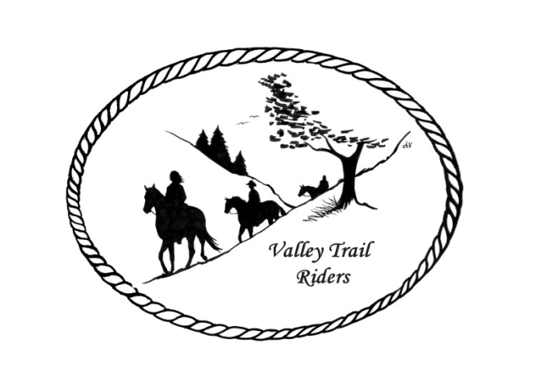 | December 2022 Newsletter

CLUB NEWS:

If you are interested in hosting an event over the winter, like a game night, bowling, or any other fun event please bring your ideas to the meeting or contact Lorrie Conry.

New meeting date and time: January – May and September – December will be at 6:30 pm on the second Tuesday of the month at the Lockwood Cookhouse in Rockford. Summer meetings will coincide with club rides that are planned by the ride Committee and will be held on Saturday nights along with a meal.

Elected Officers for the 2023 year are:
President – Lorrie Conry (815-973-2192)
Vice President – Terry Busby
Secretary – Caron Paschke
Treasurer – Carolyn Moehring
Club Board of Directors: Linda Thomas, Susan Krug, and Rose Shedd.

Liaisons to our local parks:
Rock Cut State Park: Terry Herbig
Franklin Creek State Park: Rosemarie Farmer
Seward Bluffs: Debbi Hamilton

Club Website Manager – Terry Busby --To contact Terry, please go to the website and click on support or email support@ valleytrailriders.club.

The website address is: www.Valleytrailriders.club

To access members-only side of the website which includes, Member posts, Blog articles, items for sale, club newsletter, meeting minutes, etc…
- Click on the join button.
- Fill out the form
- Click the Submit button

If you have not done so yet, please go on our website and create your member log in. Terry will approve your access to the Members Only section once he verifies your paid membership. We plan to relay most of our club information and news through the website. When you are approved, you will also be set up with your own club email address that links to your personal email address. This is so we can send group emails and members can communicate with each other without giving out their personal information.

Facebook Page - It was decided at the club meeting to only have one public Facebook group and private club correspondence would be facilitated through our Members only page on the Website. We are currently working on this.

Miscellaneous info:
- Valley Trail Riders Apparel: You can purchase hats, t-shirts, sweatshirts, etc…by contacting Rose Shedd at 815-979-5998 Rose also does bring items to our club meetings😊

Club Dues will remain the same amount as last year for dues paid before January 31. Single $15.00 Family $20.00 --After that date, there will be an additional $5.00 late fee for returning members.

Make checks payable to Valley Trail Riders and mail to:
Carolyn Moehring
3881 Page Rd,
Rockford, 61101

Calendar:
- December 11, 2022 Christmas Party at the Machine Shed in Rockford
  - Cocktail hour 4:30 – 5:30; Dinner at 5:30. Order off the menu and pay on your own. There will be a gift exchange for those who wish to participate $15-$20
Carolyn will be receiving dues that evening – CHECKS ONLY

- January 10, 2023 Club Meeting at the Lockwood Cookhouse @6:30pm (bring an appetizer or finger food to share if you like)
- February 14, 2023 Club Meeting at the Lockwood Cookhouse @6:30pm (bring a sweet treat to share if you like)
- March 14, 2023 Club Meeting at the Lockwood Cookhouse @6:30pm (Pizza Night- we will order when the meeting starts- eat afterwards)
- April 11, 2023 Club Meeting at the Lockwood Cookhouse @6:30pm (Potluck dinner- before the meeting, which will start around 7pm)
- May 9, 2023 Club Meeting at the Lockwood Cookhouse @6:30pm (bring a snack to share if you like)

