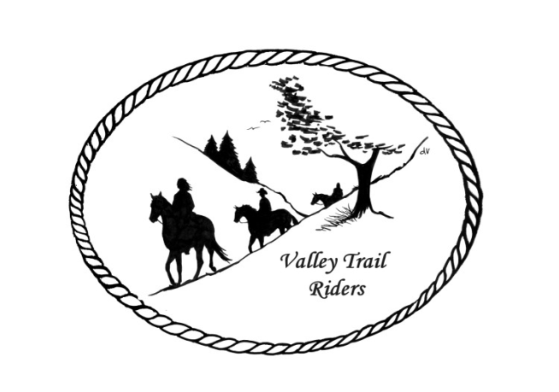
VALLEY TRAIL RIDERS CLUB NEWS
September 2026
Saturday was a lot of fun! The first trail ride began at 10:30 with Liz Longenecker leading 15-17 riders out on the trails. Thank you to Liz. At 1:00 we had paint a rock session at the pavilion. There’s a lot of talent in our club! There were horses, birds, fish, flowers, and mandala paintings (dot painting) along with a lot of laughing and bonding time too. Dinner was at 5:30. We sang Happy Birthday to Jeff Edwards, 72 years old! Food served was BBQ, potato salad, relish dish, and pasta salad. Desserts consisted of homemade cookies, blueberry crisp, cakes and pies. The game Left, Right, Center was played after dinner. Winners were Donna Howland and Cindy Edwards. Of course, great campfires were made. Event host Rose Shedd would like to thank her co-hosts Susan Krug and Darcy Cross for all their help. It was good to spend time with old and new friends who have horses in common.

There are no officer reports this month, as there were no meetings or financial activity.

The steak fry is our next event. A flyer will be attached to the email. We must have RSVP’s by the due date so we can purchase the correct amount of steak dinners.

Don’t forget to log your riding/driving hours and your activity within the club. There are categories such as serving on committees, recruiting new members, hosting weekend rides, and submitting blogs with interesting information to share. There are many ways to get more involved with the club. If you have any ideas for future events or activities, please contact an officer.
The minutes from the previous monthly meeting and the monthly Treasurer’s report are included in the monthly mailing/emailing of the newsletter each month. Please review these documents prior to the meeting, as we will dispense with the reading of the reports at the membership meetings going forward. These routine reports will be approved in one motion, as distributed and read on your own, unless there are any corrections that take place,
Officers: President -Lorrie Busby (815-973-2192); Vice President -Cindy Edwards (815-262-1224)
Secretary - Sue Reitmaier (815-289-5482); Treasurer - Rose Shedd (815-979-5998)
Club Board of Directors: Diane Feuillerat (815-980-6777), Sharon Vonderheide (815-509-4942), and Donna Howland (815-222-7345) Questions or concerns can be directed to an officer or director at any time.
ANNUAL DUES - Single -$15.00 & Family-$20.00 - Associate Member fee is $100 (Can be paid with Credit Card on the website)
Make checks payable to Valley Trail Riders and mail to: Rose Shedd, 6744 Freeport Road, Rockton, IL 61072-9426.

Committee Members:

Christmas Party: Rose Shedd (Chair), Debbi Hamilton, and Susan Krug

Social Committee: Yvonne Comm (Chair), Diane Feuillerat, Lesley Wheeler, Debbi Hamilton, and Cindy Hutcheson

Ride Committee: Donna Howland (Chair), Cindy Edwards, Jeff & Lori Edwards, Lesley Wheeler, Yvonne Comm, Cindy Hutcheson, and Lorrie Busby

Associate Membership Liaison – Melissa Myers

Liaisons to our local parks:

Rock Cut State Park: Matt & Lesley Wheeler
To report any problems at the park, call 815-979-1237

Franklin Creek State Park: Lorrie Busby

Winnebago Forest Preserves: Debbi Hamilton

Lockwood: Terry Herbig (Thanks to Rhoda Fox for being Liaison previously)

Club Website Manager – Terry Busby --To contact Terry, please go to the website and click on support or email support@ valleytrailriders.club.
The website address is: www.Valleytrailriders.club to access the members-only side of the website, click on the join button--Fill out the form --Click the Submit button. Terry will approve your access to the “Members Only” section once he verifies your paid membership. When you are approved, you will be set up with your own club email address that links to your personal email address. The Member’s only side includes: Area to submit Blog articles, club newsletter and meeting minutes, Member contacts and Club Bylaws etc…. If you have not done so yet, please go on our website and create your member log in.

Facebook Page Administrator- Kurtis Longenecker -- Please forward anything you want posted, such as pictures or events on our page to Kurtis at k_longenecker@valleytrailriders.club

Valley Trail Riders Apparel-You can purchase hats, t-shirts, sweatshirts, etc…by contacting Rose Shedd at 815-979-5998 - Rose also brings items for sale, to our club meetings😊

Miles by the Minute Badge Program (Coordinator Melissa Myers) Riding and cart driving hours are calculated from 11/1 to 10/31. You will self-report your hours to Melissa Myers @ 815-494-6595 by 10/31 every year. Applications are submitted by 1/31 every year with yearly fees. The first-year cost is $25 and $15 every subsequent year. You will receive your hoodie when you sign up. Award badges will be presented at the annual Christmas Party. Awards and prizes are subject to change.

Annual Year End Awards:
Award Categories: (1) Most Hours in the Saddle or Driving a cart (hours include #2), (2) Most Hours in the saddle or driving a cart at VTR Hosted Events, (3) Most Active Event Organizer/Committee Member/Board Member/Officer, (4) New Member Recruitment including Associate Members, (5) Website Blog Activity and Finally (6) Member of The Year based on points accumulated from the 5 categories listed above.

All VTR members are automatically eligible for this program upon payment of your annual membership dues. Points from the above categories are calculated and assigned points based on the 12-month period from November 1st to October 31st. Each of the (5) categories are awarded to first and second place. Please use the website https://valleytrailriders.club to self-report hours and activities by November 15th of each year. An alternative manual form is available on the website or from the ride committee. Please contact Donna Howland at 815-222-7345 should you require assistance.

Calendar
- September 19 & 20th^{th} - Camping & Steak Fry at Rock Cut State Park Equestrian Area. Saturday Organized Trail ride at 10:30am and Steak fry at 5:30pm. Sunday Organized Trail Ride 10:30am Hosts: Matt & Lesley Wheeler & Sharon & Mike Vonderheide 815-742-7497. Flyer attached to email

- September 27th - Morrison Rockwood State Park Trail ride 11am and Potluck at 5:30pm. Hosts: Lorrie and Terry Busby. 815-973-2192.

- October 10th & 11th -Camping & Chili Dump with RRTHA at Franklin Creek State Park. Trail ride Saturday at 11am. Chili Dump at 5:30pm. Sunday Trail ride 11am. Hosts Diane Croom/Ellen Inman. 815-761-3928.

- October 24th & 25th - Camping Weekend & Halloween Spooktacular at Rock Cut Equestrian Area Saturday Costume Contest at 12 noon & Scary Trail Ride at 1 pm. Creepy Crawley Potluck at
5 pm. Sunday Trail ride at 11am. Hosts: Melissa Meyers/Sue & John Reitmaier. 815-494-6595.

- November 7th & 8th - Camping Weekend at Oak Ridge Forest Preserve, Cherry Valley, IL. Saturday Flannel Shirt Ride (Wear your Flannel) Trail ride at 11am. Potluck 5pm. Sunday Trail Ride at 11am Hosts: Cindy Edwards/Donna Howland 815-262-1224

- January 16, 2027 -Christmas Banquet and Awards Ceremony will be at Belvidere American Legion. There will be a DJ and Silent Auction. Catering is undecided at this time.

RRTHA 2026 Ride Schedule -Franklin Creek State Park
➢ September 13 – Fun Show w/ Breakfast morning of
➢ October 10 – 11 – Chili Dump in conjunction with Valley Trail Riders

