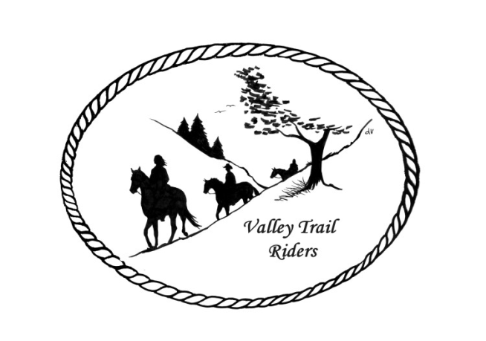
VALLEY TRAIL RIDERS CLUB NEWS
June 2026

Clean up day at Rock Cut was held on May 16th. There were about 15 members in attendance and much work was completed. Thanks to Matt and Leslie Wheeler for all their hard work and coordination of the event. The Clinic with Mary Hougan of Equistroke that was held at Donna Howland’s arena was a great success! We learned all about helping our horses with emotional regulation//support and relaxation. There were 11 people in attendance. Thanks to Donna for hosting at her barn. Thanks to Cindy Edwards for providing Rocket as our demo pony Our first group ride to Weinberg King was a hit with nine members and one guest attending. The park offered a beautiful forest preserve with many creek crossings. It also had a nice camp ground with level parking sites. Many commented they would like to go back. Thanks to Pam Carter and Cindy Hutcheson who hosted this event!
Don’t forget to log your riding/driving hours, your activity within the club like serving on committees or recruiting new members; along with submit blogs with interesting information to share. There are many ways to get more involved with the club. If you have ideas for a far-away ride or want to host something at your home, please get in touch with the Ride Committee or Social Committee. Many involved makes for fun opportunities for all!!
The minutes from the previous monthly meeting and the monthly Treasurer’s report are included in the monthly mailing/emailing of the newsletter each month. Please review these documents prior to the meeting, as we will dispense with the reading of the reports at the membership meetings going forward. These routine reports will be approved in one motion, as distributed and read on your own, unless there are any corrections that take place at the next membership meeting.
FYI – All 2026 events are posted on the website calendar.
Officers: President -Lorrie Busby (815-973-2192); Vice President -Cindy Edwards (815-262-1224)
Secretary - Sue Reitmaier (815-289-5482); Treasurer - Rose Shedd (815-979-5998)
Club Board of Directors: Diane Feuillerat (815-980-6777), Sharon Vonderheide (815-509-4942), and Donna Howland (815-222-7345) Any questions or concerns can be directed to an officer or director at any time.
ANNUAL DUES - Single -$15.00 & Family-$20.00 - Associate Member fee is $100
Make checks payable to Valley Trail Riders and mail to: Rose Shedd, 6744 Freeport Road, Rockton, IL 61072-9426.

Committee Members:
Christmas Party: Rose Shedd (Chair), Debbi Hamilton, and Susan Krug

Social Committee: Yvonne Comm (Chair), Diane Feuillerat, Lesley Wheeler, Debbi Hamilton, and Cindy Hutcheson

Ride Committee: Donna Howland (Chair), Cindy Edwards, Jeff & Lori Edwards, Lesley Wheeler, Yvonne Comm, Cindy Hutcheson, and Lorrie Busby

Associate Membership Liaison – Melissa Myers

Liaisons to our local parks:

Rock Cut State Park: Matt & Lesley Wheeler
To report any problems at the park, call 815-979-1237

Franklin Creek State Park: Lorrie Busby

Winnebago Forest Preserves: Debbi Hamilton

Club Website Manager – Terry Busby --To contact Terry, please go to the website and click on support or email support@ valleytrailriders.club.
The website address is: www.Valleytrailriders.club To access the members-only side of the website, click on the join button--Fill out the form --Click the Submit button. Terry will approve your access to the “Members Only” section once he verifies your paid membership. When you are approved, you will be set up with your own club email address that links to your personal email address. The Member’s only side includes: Area to submit Blog articles, club newsletter and meeting minutes, Member contacts and Club Bylaws etc…. If you have not done so yet, please go on our website and create your member log in.

There is a button on our website now for Associate Members to pay with a credit card.
Facebook Page Administrator- Kurtis Longenecker -- Please forward anything you want posted, such as pictures or events on our page to Kurtis at k_longenecker@valleytrailriders.club

Valley Trail Riders Apparel-You can purchase hats, t-shirts, sweatshirts, etc…by contacting Rose Shedd at 815-979-5998 - Rose also brings items for sale, to our club meetings😊

Miles by the Minute Badge Program (Coordinator Melissa Myers) Riding and cart driving hours are calculated from 11/1 to 10/31. You will self-report your hours to Melissa Myers @ 815-494-6595 by 10/31 every year. Applications are submitted by 1/31 every year with yearly fees. The first-year cost is $25 and $15 every subsequent year. You will receive your hoodie when you sign up. Award badges will be presented at the annual Christmas Party. Awards and prizes are subject to change.

Annual Year End Awards:
Award Categories: (1) Most Hours in the Saddle or Driving a cart (hours include #2), (2) Most Hours in the saddle or driving a cart at VTR Hosted Events, (3) Most Active Event Organizer/Committee Member/Board Member/Officer, (4) New Member Recruitment including Associate Members, (5) Website Blog Activity and Finally (6) Member of The Year based on points accumulated from the 5 categories listed above.

All VTR members are automatically eligible for this program upon payment of your annual membership dues. Points from the above categories are calculated and assigned points based on the 12-month period from November 1st to October 31st. Each of the (5) categories are awarded to first and second place. Please use the website https://valleytrailriders.club to self-report hours and activities by November 15th of each year. An alternative manual form is available on the website or from the ride committee. Please contact Donna Howland at 815-222-7345 should you require assistance.

Calendar

- June 6 – 7th Rock Cut Campfire Cooking Weekend hosted by Lori and Jeff Edwards. Saturday Trail rides at 10am & 1:30pm with Campfire cooking dinner at 6pm. Sunday Trail ride at 10:30am.

- June 25-28th Prairie Du Chien camping at LaRiviere Park hosted by Matt & Lesley Wheeler

- July 4th Patriotic Camping Weekend. Franklin Creek Equestrian Area. Trail ride at 10:30am. Potluck at the pavilion at 5:30 Hosts for the event Lorrie Busby and Melinda Temple

- July 5th Trail Ride at 10:30am Franklin Creek Equestrian Area. Dine and Dash 2pm – 4pm at member campsites. You can participate by hosting a camp tour of your campsite and serve a light appetizer and /or beverage.

- July 18th Camping weekend at Seward Bluffs. Bring your Pie Irons. Trail ride at 10:30am, Potluck at 5:30pm. Hosted by Lorrie and Terry Busby.

- July 19th Trail ride at 10:30am Seward Bluffs

RRTHA 2026 Ride Schedule -Franklin Creek State Park
June 6– 7 – Burgers & Dogs
➢ July 11– 12 – Tacos
➢ August 29 @9pm – 30 @ 10am – Scavenger Hunt & Moonlight Ride
➢ September 13 – Fun Show w/ Breakfast morning of
➢ October 10 – 11 – Chili Dump in conjunction with Valley Trail Riders

