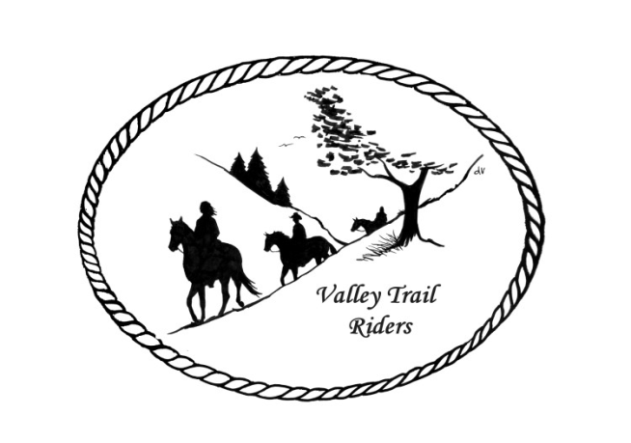
VALLEY TRAIL RIDERS CLUB NEWS
December 2025
A huge thank you goes out to all the Officers and Committee members who served in 2025. Your dedication to the club and hours donated to help out is greatly appreciated!!
Our final event of the year is coming up on December 6th. The Christmas Party Committee has planned a great event again this year with good food from Mission BBQ, Dancing to the “Just for Fun” band, and a silent auction with many great baskets to bid on. All proceeds go in the club treasury.
The minutes from the previous monthly meeting and the monthly Treasurer’s report are included in the monthly mailing/emailing of the newsletter each month. Please review these documents prior to the meeting, as we will dispense with the reading of the reports at the membership meetings going forward. These routine reports will be approved in one motion, as distributed and read on your own, unless there are any corrections that take place at the next membership meeting.
Officers: President -Lorrie Busby (815-973-2192)
Vice President -Yvonne Comm (847-409-8678) --- VP for 2026 is Cindy Edwards
Secretary - Caron Paschke (815-289-9389) --- Secretary for 2026 is Sue Reitmaier
Treasurer - Rose Shedd (815-979-5998)
Club Board of Directors for 2025: Diane Feuillerat (815-980-6777), Sharon Vonderheide (815-509-4942), and Donna Howland (815-222-7345) -All have been reelected for 2026
Any questions or concerns can be directed to an officer or director at any time.
Club dues and Miles by the Minute for 2026 can be sent in any time now and also can be paid at the Christmas Party
DUES - Single -$15.00 & Family-$20.00 - Associate Member fee is $100
Make checks payable to Valley Trail Riders and mail to: Rose Shedd, 6744 Freeport Road, Rockton, IL 61072-9426.

Committee Members:

Christmas Party 2026: Rose Shedd (Chair), Debbi Hamilton, Yvonne Comm, and Susan Krug

Social Committee 2026: Yvonne Comm (Chair), Diane Feuillerat, Lesley Wheeler, Debbi Hamilton, and Cindy Hutcheson

Ride Committee 2026: Donna Howland (Chair), Cindy Edwards, Jeff & Lori Edwards, Lesley Wheeler, Yvonne Comm, Cindy Hutcheson, and Lorrie Busby

If you wish to serve on a committee, please contact the chairperson or Lorrie Busby to get connected!!

Associate Membership Liaison – Melissa Myers

Liaisons to our local parks:

Rock Cut State Park: Matt Wheeler
To report any problems at the park, call 815-979-1237

Franklin Creek State Park: Barrett Manning

Winnebago Forest Preserves: Debbi Hamilton

Club Website Manager – Terry Busby --To contact Terry, please go to the website and click on support or email support@ valleytrailriders.club.
The website address is: www.Valleytrailriders.club To access the members-only side of the website, click on the join button--Fill out the form --Click the Submit button. Terry will approve your access to the “Members Only” section once he verifies your paid membership. When you are approved, you will be set up with your own club email address that links to your personal email address. The Member’s only side includes: Area to submit Blog articles, club newsletter and meeting minutes, Member contacts and Club Bylaws etc…. If you have not done so yet, please go on our website and create your member log in.

Facebook Page Administrator- Kurtis Longenecker -- Please forward anything you want posted, such as pictures or events on our page to Kurtis at k_longenecker@valleytrailriders.club

Valley Trail Riders Apparel-You can purchase hats, t-shirts, sweatshirts, etc…by contacting Rose Shedd at 815-979-5998 - Rose also brings items for sale, to our club meetings😊

Miles by the Minute Badge Program (Coordinator Melissa Myers) Riding and cart driving hours are calculated from 11/1 to 10/31. You will self-report your hours to Melissa Myers @ 815-494-6595 by 10/31 every year. Applications are submitted by 1/31 every year with yearly fees. The first-year cost is $25 and $15 every subsequent year. You will receive your hoodie when you sign up. Award badges will be presented at the annual Christmas Party. Awards and prizes are subject to change.

Annual Year End Awards:
Award Categories: (1) Most Hours in the Saddle or Driving a cart (hours include #2), (2) Most Hours in the saddle or driving a cart at VTR Hosted Events, (3) Most Active Event Organizer/Committee Member/Board Member/Officer, (4) New Member Recruitment including Associate Members, (5) Website Blog Activity and Finally (6) Member of The Year based on points accumulated from the 5 categories listed above.

All VTR members are automatically eligible for this program upon payment of your annual membership dues. Points from the above categories are calculated and assigned points based on the 12-month period from November 1st to October 31st. Each of the (5) categories are awarded to first and second place. Please use the website https://valleytrailriders.club to self-report hours and activities by November 15th of each year. An alternative manual form is available on the website or from the ride committee. Please contact Donna Howland at 815-222-7345 should you require assistance.

Calendar

- December 6th VTR Christmas Party at the Jarrett Prairie Center, Byron, IL
5:30 pm cocktails --6pm banquet dinner (Mission BBQ) and award presentations to follow --Silent Auction open till 9pm Band will be “Just 4 Fun”

- December 7th Social Committee Meeting at Thunder Bay Grill in Rockford @1:30pm. If you wish to join the committee, please feel free to attend.

- January 3rd Officers and Directors Meeting at 1pm - Lorrie Busby’s home

- January 13th Club meeting 6:30 pm at the Cookhouse at Lockwood Park, 5201 Safford Rd,, Rockford, IL

- February 7th Game Day at the Busby Barn -Noon – 4. Potluck lunch -Bring quarters if you want to play LRC

- February 10th Club meeting 6:30 pm at the Cookhouse at Lockwood Park, 5201 Safford Rd,, Rockford, IL

- March 10th Club meeting 6:30 pm at the Cookhouse at Lockwood Park, 5201 Safford Rd,, Rockford, IL

- April 14th Club meeting 6:30 pm at the Cookhouse at Lockwood Park, 5201 Safford Rd,, Rockford, IL

- May 16th Work Day at Rock Cut State Park Equestrian Area. Club Meeting 6:30 pm at the park. More details of the weekend to follow.

