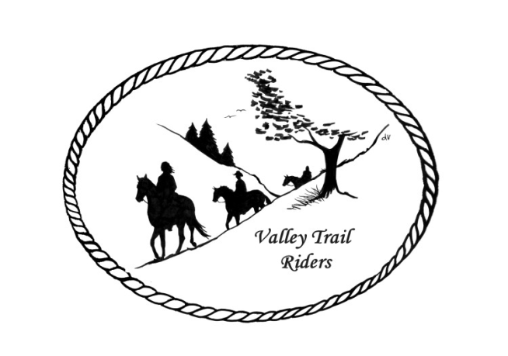
VALLEY TRAIL RIDERS CLUB NEWS
September 2025
Valley Trail Rider’s Obstacle event with arena games was a hit again this year. Liz Longenecker did a great job setting up a super fun course and many members enjoyed it!! The Steak Fry is our next event. This is an annual tradition and we hope all will be able to make it. The flyer was sent out in a separate mailing.

Lorrie and Terry Busby would like to host a barn sale at their place this fall, with all proceeds to go to the club. This would be a club fundraiser. If you are interested in bringing/donating items, please contact Lorrie via text message or call (815-973-2192) by September 5th. We will see if there is enough interest to go forward with this.
If you plan on donating items for the silent auction at our Christmas Party, please contact Caron (815-289-9389) to let the committee know what to expect. It is a bit difficult to receive items the night of the party, as we need to have bid sheets prepared for each basket/item.
Reminder to record your minutes riding for Miles by the Minute Badge Program and the Annual Year End Awards.
There are no Officer Reports from August, since we had no club meeting and there was no financial activity.
Officers: President -Lorrie Busby (815-973-2192); Vice President -Yvonne Comm (847-409-8678); Secretary - Caron Paschke (815-289-9389); Treasurer - Rose Shedd (815-979-5998)
Club Board of Directors for 2025: Diane Feuillerat (815-980-6777), Sharon Vonderheide (815-509-4942), and Donna Howland (815-222-7345)
Any questions or concerns can be directed to an officer or director at any time.
DUES - Single -$15.00 & Family-$20.00 - Associate Member fee is $100
Make checks payable to Valley Trail Riders and mail to: Rose Shedd, 6744 Freeport Road, Rockton, IL 61072-9426.

Committee Members:

Christmas Party: Caron Paschke (Chair), Debbi Hamilton, Yvonne Comm, Rose Shedd, Lorrie Busby, and Susan Krug

Social Committee: Yvonne Comm (Chair), Diane Feuillerat, Lesley Wheeler, and Lorrie Busby

Ride Committee: Liz Longenecker (Chair), Donna Howland, Cindy Edwards, Melissa Myers, and Chris Darmon

Social Media Committee: Webpage Administrator-Terry Busby; FaceBook Page Administrator– Kurtis Longenecker; Media Assistant -Melissa Myers

Liaisons to our local parks:

Rock Cut State Park: Terry Herbig – To report any problems at the park call 815-979-1237
Franklin Creek State Park: Linda Odom
Winnebago Forest Preserves: Debbi Hamilton

Club Website Manager – Terry Busby --To contact Terry, please go to the website and click on support or email support@ valleytrailriders.club.
The website address is: www.Valleytrailriders.club To access the members-only side of the website, click on the join button--Fill out the form --Click the Submit button. Terry will approve your access to the “Members Only” section once he verifies your paid membership. When you are approved, you will be set up with your own club email address that links to your personal email address. The Member’s only side includes: Area to submit Blog articles, club newsletter and meeting minutes, Member contacts and Club Bylaws etc…. If you have not done so yet, please go on our website and create your member log in.

Facebook Page Administrator- Kurtis Longenecker -- Please forward anything you want posted, such as pictures or events on our page to Kurtis at k_longenecker@valleytrailriders.club

Valley Trail Riders Apparel-You can purchase hats, t-shirts, sweatshirts, etc…by contacting Rose Shedd at 815-979-5998 - Rose also brings items for sale, to our club meetings😊

Miles by the Minute Badge Program: Riding and cart driving hours are calculated from 11/1 to 10/31. You will self-report your hours to Melissa Myers @ 815-494-6595 by 10/31 every year. Applications are submitted by 1/31 every year with yearly fees. The first-year cost is $25 and $15 every subsequent year. You will receive your hoodie when you sign up. Award badges will be presented at the annual Christmas Party. Awards and prizes are subject to change.
Annual Year End Awards:
Award Categories: (1) Most Hours in the Saddle or Driving a cart (hours include #2), (2) Most Hours in the saddle or driving a cart at VTR Hosted Events, (3) Most Active Event Organizer/Committee Member/Board Member/Officer, (4) New Member Recruitment including Associate Members, (5) Website Blog Activity and Finally (6) Member of The Year based on points accumulated from the 5 categories listed above.

All VTR members are automatically eligible for this program upon payment of your annual membership dues. Points from the above categories are calculated and assigned points based on the 12-month period from November 1st to October 31st. Each of the (5) categories is awarded to first and second place. Please use the website https://valleytrailriders.club to self-report hours and activities by November 15th of each year. An alternative manual form is available on the website or from the ride committee. Please contact Donna Howland at 815-222-7345 should you require assistance.

Calendar

- September 13th Steak Fry at Rock Cut Equestrian Area
Dine and Dash (Hosted by Liz) 10 am to 11:30 am - Trail ride @1pm - Social Committee will host the steak meal at 5:30 pm with Club meeting afterwards (approximately 6:30) Reservations due by September 5th – pay at the event
- September 14th Trail ride 9:30 am. Rock Cut Equestrian Area
- September 27th Flannel Shirt Ride at Rockwood State Park in Morrison 10am hosted by Caron Paschke and Lorrie Busby. Wear your flannel! Potluck dinner at 5:30 pm
- September 28th Trail Ride 9:30 am at Rockwood State Park

- October 8 – 13th Far Away Ride at High Knob – Shawnee National Forest – Hosted by Lori Brose and Susan Krug. October 11 and 12 count as club rides for logging your minutes.
- October 18th Halloween Spooktacular Ride at Rock Cut hosted by Melissa Myers and Chris Darmon. Costume contest at noon with a Scary Trail Ride at 1 pm. Creepy Crawley Potluck at 5 pm. Club meeting at 6 pm. Horse energy session with Yvonne Comm after the meeting
- October 19th Trail ride 9:30 am Rock Cut Equestrian Area

- November 8th Find the Clue/Chili Dump at Oak Ridge Forest Preserve, 8321 Blomberg Rd, Cherry Valley, IL--Hosted by Donna Howland and Cindy Edwards. Trail ride-10:30 am --Chili Dump 3:30 pm/Bring some chili to dump and a dish to pass
- November 9th Trail ride 9:30 am Oak Ridge Forest Preserve
- November 11th Club meeting 6:30 pm at the Cookhouse at Lockwood Park, 5201 Safford Rd,, Rockford, IL -Bring an appetizer to share if you like.
- December 6th VTR Christmas Party at the Jarrett Prairie Center, Byron, IL
5:30 pm cocktails --6pm banquet dinner (Mission BBQ) and award presentations to follow --Silent Auction open till 9pm Band will be “Just 4 Fun” Reservations due by November 18th - $30 per person Send your check to Rose Shedd, 6744 Freeport Road, Rockton, IL 61072-9426

Watch the website, Facebook, emails, and Newsletters for more details about events

