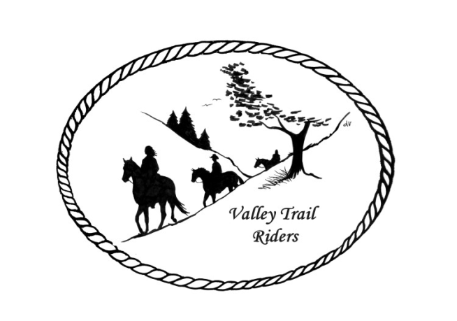
VALLEY TRAIL RIDERS CLUB NEWS
July 2025
The month of June was hit with some hot weather and our obstacle course event was cancelled. However, the tack swap was a great event and many attended. Our Vice President Yvonne Comm endured the heat and grilled hot dogs and brats for our potluck. Thanks Yvonne!! We had technical difficulties and our movie night had to be cancelled, but everyone enjoyed a nice campfire. Our Patriotic weekend event had to also be cancelled due to the extreme heat forecasted, but the weather is to be back in the 80’s on Sunday, so there will be a club trail ride on Sunday July 6th at 9am and potluck to follow.
There will be no club meeting in July.
The minutes from the previous monthly meeting and the monthly Treasurer’s report are included in the monthly mailing/emailing of the newsletter each month. Please review these documents prior to the meeting, as we will dispense with the reading of the reports at the membership meetings going forward. These routine reports will be approved in one motion, as distributed and read on your own, unless there are any corrections that take place at the membership meeting.
Officers: President -Lorrie Busby (815-973-2192); Vice President -Yvonne Comm (847-409-8678); Secretary - Caron Paschke (815-289-9389); Treasurer - Rose Shedd (815-979-5998)
Club Board of Directors for 2025: Diane Feuillerat (815-980-6777), Sharon Vonderheide (815-509-4942), and Donna Howland (815-222-7345)
Any questions or concerns can be directed to an officer or director at any time.
DUES - Single -$15.00 & Family-$20.00 - Associate Member fee is $100
Make checks payable to Valley Trail Riders and mail to: Rose Shedd, 6744 Freeport Road, Rockton, IL 61072-9426.

Committee Members:

Christmas Party: Caron Paschke (Chair), Debbi Hamilton, Yvonne Comm, Rose Shedd, Lorrie Busby, and Susan Krug

Social Committee: Yvonne Comm (Chair), Diane Feuillerat, Lesley Wheeler, and Lorrie Busby

Ride Committee: Liz Longenecker (Chair), Donna Howland, Cindy Edwards, Melissa Myers, and Chris Darmon

Social Media Committee: Webpage Administrator-Terry Busby; FaceBook Page Administrator– Kurtis Longenecker; Media Assistant -Melissa Myers

Liaisons to our local parks:

Rock Cut State Park: Terry Herbig – To report any problems at the park call 815-979-1237
Franklin Creek State Park: Linda Odom
Winnebago Forest Preserves: Debbi Hamilton

Club Website Manager – Terry Busby --To contact Terry, please go to the website and click on support or email support@ valleytrailriders.club.
The website address is: www.Valleytrailriders.club To access the members-only side of the website, click on the join button--Fill out the form --Click the Submit button. Terry will approve your access to the “Members Only” section once he verifies your paid membership. When you are approved, you will be set up with your own club email address that links to your personal email address. The Member’s only side includes: Area to submit Blog articles, club newsletter and meeting minutes, Member contacts and Club Bylaws etc…. If you have not done so yet, please go on our website and create your member log in.

Facebook Page Administrator- Kurtis Longenecker -- Please forward anything you want posted, such as pictures or events on our page to Kurtis at k_longenecker@valleytrailriders.club

Valley Trail Riders Apparel-You can purchase hats, t-shirts, sweatshirts, etc…by contacting Rose Shedd at 815-979-5998 - Rose also brings items for sale, to our club meetings😊

Miles by the Minute Badge Program: Riding and cart driving hours are calculated from 11/1 to 10/31. You will self-report your hours to Melissa Myers @ 815-494-6595 by 10/31 every year. Applications are submitted by 1/31 every year with yearly fees. The first-year cost is $25 and $15 every subsequent year. You will receive your hoodie when you sign up. Award badges will be presented at the annual Christmas Party. Awards and prizes are subject to change.
Annual Year End Awards:
Award Categories: (1) Most Hours in the Saddle or Driving a cart (hours include #2), (2) Most Hours in the saddle or driving a cart at VTR Hosted Events, (3) Most Active Event Organizer/Committee Member/Board Member/Officer, (4) New Member Recruitment including Associate Members, (5) Website Blog Activity and Finally (6) Member of The Year based on points accumulated from the 5 categories listed above.

All VTR members are automatically eligible for this program upon payment of your annual membership dues. Points from the above categories are calculated and assigned points based on the 12-month period from November 1st to October 31st. Each of the (5) categories is awarded to first and second place. Please use the website https://valleytrailriders.club to self-report hours and activities by November 15th of each year. An alternative manual form is available on the website or from the ride committee. Please contact Donna Howland at 815-222-7345 should you require assistance.

Calendar

- July 6th Ride at 9am Franklin Creek State Park with potluck to follow.
- July 19th Members only Dine and Splash 12 pm to 5 pm. Hosted by Melissa Myers and Liz Longenecker at Liz’s residence. Cookout and cool off. Bring floatable devices to play in the pond.
- August 23rd Obstacle course ride at Franklin Creek Equestrian Area 9 am – noon. Hosted by Liz Longenecker and Melissa Myers. Social Committee will host a “cold foods” potluck at 5:30 with Club Meeting to follow and crafts afterwards at the pavilion.
- August 24th Trail ride 9:30 am. Rock Cut Equestrian Area.

- September 13th Steak Fry at Rock Cut with Dine and Dash 10 am to 11:30 am. Social Committee will host the steak meal at 5:30 pm with Club meeting afterwards (approximately 6:30)
- September 14th Trail ride 9:30 am. Rock Cut Equestrian Area.
- September 27th Flannel Shirt Ride at Rockwood State Park in Morrison at 10 am hosted by Caron Paschke and Lorrie Busby. Wear your flannel! Potluck dinner at 5:30 pm
- September 28th Trail Ride 9:30 am at Rockwood State Park.

- October 8 – 13th Far Away Ride at High Knob – Shawnee National Forest – Hosted by Lori Brose and Susan Krug. October 11 and 12 count as club rides for logging your minutes.
- October 18th Halloween Spooktacular Ride at Rock Cut hosted by Melissa Myers and Chris Darmon. Costume contest at noon with a Scary Trail Ride at 1 pm. Creepy Crawley Potluck at 5 pm. Club meeting at 6 pm. Horse energy session with Yvonne Comm after the meeting.
- October 19th Trail ride 9:30 am Rock Cut Equestrian Area.

- November 8th Find the Clue/Chili Dump at Oak Ridge Forest Preserve hosted by Donna Howland and Cindy Edwards.
- November 9th Trail ride 9:30 am Oak Ridge Forest Preserve.
- November 11th Club meeting at the Cookhouse at Lockwood Park at 6:30 pm
- December 6th Christmas Banquet

Watch the website, Facebook, and Newsletters for more details about events

