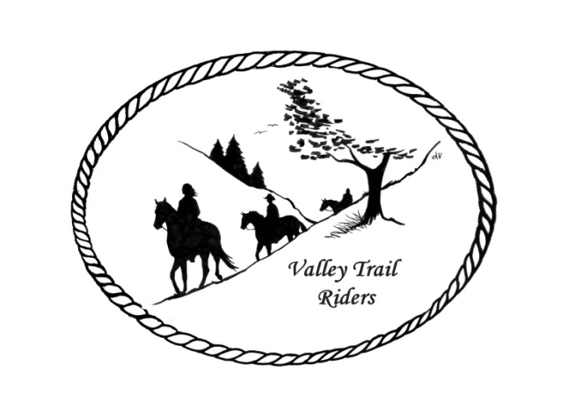

**VALLEY TRAIL RIDERS CLUB NEWS**

**April 2025**

There is an event coming up soon you might be interested in:

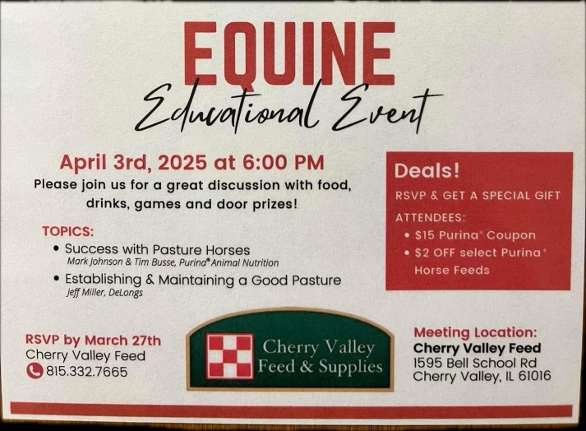

Please welcome our newest club member Jackie Grano!! We also have new Associate Members this month. Please check out the website for more information on JT Designs, Belvidere Auto Body and Finishing, and Marengo Auto Body and Glass.

The minutes from the previous monthly meeting and the monthly Treasurer’s report are included in the monthly mailing/emailing of the newsletter. Please review these documents prior to the meeting, as we will dispense with the reading of the reports at the membership meetings going forward. These routine reports will be approved in one motion, as distributed and read on your own, unless there are any corrections that take place at the membership meeting.

Please check out the calendar and mark your calendars for the season!! The Ride Brochure is out and copies are available at the meetings. There are events planned through November and our Christmas Party is already planned for December!! If you would like to host a ride, please contact the ride committee. There are lots of great opportunities to have fun with your horses and get to know/meet other club members. Hope to see you all soon on the trails!!

**Officers:** President -Lorrie Busby (815-973-2192); Vice President -Yvonne Comm (847-409-8678); Secretary - Caron Paschke (815-289-9389); Treasurer - Rose Shedd (815-979-5998)

**Club Board of Directors for 2025:** Diane Feuillerat (815-980-6777), Sharon Vonderheide (815-509-4942), and Donna Howland (815-222-7345)

Any questions or concerns can be directed to an officer or director at any time.

**DUES - Single -$15.00 & Family**-**$20.00** Make checks payable to **Valley Trail Riders** and mail to: Rose Shedd, 6744 Freeport Road, Rockton, IL 61072-9426 **If you were a member in 2024 and have not renewed your membership, it will be assessed an additional charge of $5.**

Associate Member fee is $100. If you are interested for your business please reach out to Melissa Meyers.

**Committee Members:**

**Christmas Party:** Caron Paschke (Chair), Debbi Hamilton, Yvonne Comm, Rose Shedd, Lorrie Busby, and Susan Krug

**Social Committee:** Yvonne Comm (Chair), Diane Feuillerat, Lesley Wheeler, and Lorrie Busby

**Ride Committee:** Liz Longenecker (Chair), Donna Howland, Cindy Edwards, Melissa Myers, and Chris Darmon

**Social Media Committee:** Webpage Administrator-Terry Busby; FaceBook Page Administrator– Kurtis Longenecker; Media Assistant -Melissa Myers

**Ad Hoc Committee:** (Associate Memberships) – Melissa Myers (Chair), Lorrie Busby, Caron Paschke, Chris Darmon, and Terry Busby.

**Liaisons to our local parks:**

***Rock Cut State Park:*** Terry Herbig – To report any problems at the park call 815-979-1237

***Franklin Creek State Park:*** Linda Odom & ***Winnebago Forest Preserves:*** Debbi Hamilton

**Club Website Manager –** Terry Busby --To contact Terry, please go to the website and click on support or email **support@ valleytrailriders.club.**

The website address is: [**www.Valleytrailriders.club**](http://www.Valleytrailriders.club)To access the members-only side of the website, click on the join button--Fill out the form --Click the Submit button. Terry will approve your access to the “Members Only” section once he verifies your paid membership. When you are approved, you will be set up with your own club email address that links to your personal email address. The Member’s only side includes: Area to submit Blog articles, club newsletter and meeting minutes, Member contacts and Club Bylaws etc…. If you have not done so yet, please go on our website and create your member log in.

**Facebook Page Administrator**- Kurtis Longenecker -- Please forward anything you want posted, such as pictures or events on our page to Kurtis at [k_longenecker@valleytrailriders.club](mailto:k_longenecker@valleytrailriders.club)

**Valley Trail Riders Apparel**-You can purchase hats, t-shirts, sweatshirts, etc…by contacting Rose Shedd at 815-979-5998 - Rose also brings items for sale, to our club meetings😊

**Miles by the Minute Badge Program:** Riding and cart driving hours are calculated from 11/1 to 10/31 You will self-report your hours to Melissa Myers @ 815-494-6595 by 10/31 every year. Applications are submitted by 1/31 every year with yearly fees. The first-year cost is $25 and $15 every subsequent year. You will receive your hoodie when you sign up. Award badges will be presented at the annual Christmas Party. Awards and prizes are subject to change.

**Annual Year End Awards:**

Award Categories: (1) Most Hours in the Saddle or Driving a cart (hours include #2), (2) Most Hours in the saddle or driving a cart at VTR Hosted Events, (3) Most Active Event Organizer/Committee Member/Board Member/Officer, (4) New Member Recruitment, (5) Website Blog Activity and Finally (6) Member of The Year based on points accumulated from the 5 categories listed above.

All VTR members are automatically eligible for this program upon payment of your annual membership dues.  Points from the above categories are calculated and assigned points based on the 12-month period from November 1st to October 31st.  Each of the (5) categories is awarded to first and second place.  Please use the website https://valleytrailriders.club to self-report hours and activities by November 15th of each year.  An alternative manual form is available on the website or from the ride committee.  Please contact Donna Howland at 815-222-7345 should you require assistance.

**Calendar**

* April 8th meeting at the Lockwood Cookhouse @ 6:30. It is located at 5201 Safford Road, Rockford. Peter Hays and Mary Ann Wilkens will speak on Dousing, which is the Ancient Art of locating things underground ie water, metal, oil…. Bring a snack to share.
* April 26th Clinic at Donna Howland’s arena. Mary Hougan of EquiStroke will be speaking and demonstrating an “Intro to Liberty.” This will be an audit only event with a registration fee of $50. Please contact Lorrie @815-973-2192 if you are interested.
* May 3rd will be a Kentucky Derby Party at Donna Howland’s home. Details to come.
* May 17th will be our clean-up day at Rock Cut Equestrian Park and trails from 9am – 12pm. Pizza lunch will be provided by the club at 12:30 pm. RAIN DATE IS MAY 18TH. Trail Ride at 1:30pm and potluck at 5:30 pm. Club meeting at 6:30 pm
* May 18th Trail Ride 9:30 am Rock Cut Equestrian Area
* May 26th Memorial Day Parade in Pecatonica. Meet at the Middle School, 1300 Main St., at noon to decorate the float. Parade begins at 2pm.
* June 7th Tack Swap. Set-up 8 am. Swap 9 am to 12 noon. Trail Ride 1 pm. Potluck 5:30 pm. Club meeting 6:30 pm. Rock Cut Equestrian Area.
* June 8th Trail ride. 9:30 am. Rock Cut Equestrian Area.
* June 21st: Equestrian Fun Game Day and Obstacle Challenge. 9 am to 12 noon. Trial ride 1 pm. Potluck 5:30 pm. Franklin Creek Equestrian Area. Club meeting 6:30 pm.
* June 22nd Trail Ride. 9:30 am. Franklin Creek Equestrian Area.

**Member Spotlights**

**Debbi Hamilton** lives in Winnebago and owns a Paint horse named Lady (Zippins Charming Lady). She rides Western in trail and ranch, preferring places like Mystery Cave, Governor Dodge, Wildcat, Lowden Miller, and beachfronts. Debbi has been with VTR for 10 years and has loved horses since childhood. As a young girl she would seek out a trail ride while on vacation with her parents. Her career includes roles as an Aftermarket buyer, bookkeeper, supervisor, mother, and currently, a teacher's aide. Besides riding, she enjoys spending time with her dog Cowboy, organizing, gardening, watching TV, and road trips. Debbi says she is shy and quiet until she gets to know you.

**Diane Feuillerat**, a resident of Rockton, owns three Tennessee Walking horses: Sweetie, Sage, and Scout. She enjoys western riding, trail riding, and camping, especially at Lake Le Aqua Na State Park. Diane joined the VTR 25-30 years ago and has been passionate about horses for 65 years. Her earliest memory is riding a Welsh pony named Sugar and pulling friends on a toboggan. She loved to go fast and turn a fast corner to dump her friends in the snow! Diane's career was in Kitchen Design and sales. A fun fact is she loves speeding in her UTV.

**Lesley Wheeler**, from Poplar Grove, owns a Tennessee walking horse named Amigo. She rides western, enjoying gentle trail rides, especially at Franklin Creek. A VTR member for 40 years, she is now retired and enjoys boating and hiking. Her earliest horse memory is buying a horse at auction as a surprise for her family.

**Liz Longenecker** lives in Pecatonica and owns a Quarter Horse named Jazziple, aka Jazzi. She rides Western style and loves to ride at Rock Cut and Lockwood. Liz has been interested in horses since childhood, first riding her cousin’s ponies. She also enjoys dogs, and she absolutely loves to create obstacle courses!  Her occupation is in medical hospital scheduling.