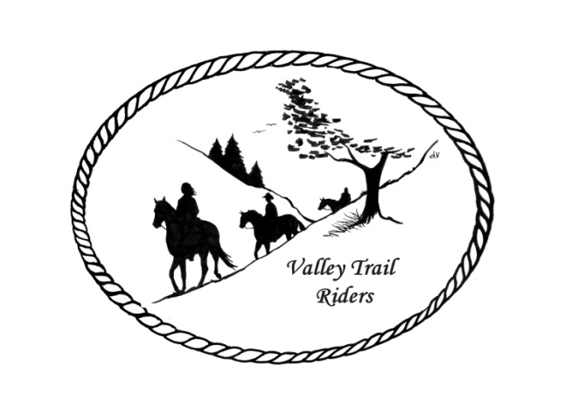

**VALLEY TRAIL RIDERS CLUB NEWS**

**March 2025**

We had a great turn out for game day!! Lots of fun with several different games played and yummy food as usual. Thanks to all who came!!

All our events through May are on the calendar. The ride brochure will be out this month with events for the rest of the year. Lots going on with the Valley Trail Riders!!!

The minutes from the previous monthly meeting and the monthly Treasurer’s report are included in the monthly mailing/emailing of the newsletter. Please review these documents prior to the meeting, as we will dispense with the reading of the reports at the membership meetings going forward. These routine reports will be approved in one motion, as distributed and read on your own, unless there are any corrections that take place at the membership meeting.

**Officers:** President -Lorrie Busby (815-973-2192); Vice President -Yvonne Comm (847-409-8678); Secretary - Caron Paschke (815-289-9389); Treasurer - Rose Shedd (815-979-5998)

**Club Board of Directors for 2025:** Diane Feuillerat (815-980-6777), Sharon Vonderheide (815-509-4942), and Donna Howland (815-222-7345)

Any questions or concerns can be directed to an officer or director at any time.

**DUES - Single -$15.00 & Family**-**$20.00** Make checks payable to **Valley Trail Riders** and mail to: Rose Shedd, 6744 Freeport Road, Rockton, IL 61072-9426 **If you were a member in 2024 and have not renewed your membership, it will be assessed an additional charge of $5.**

Associate Member fee is $100. If you are interested for your business please reach out to Melissa Meyers.

**Committee Members:**

**Christmas Party:** Caron Paschke (Chair), Debbi Hamilton, Yvonne Comm, Rose Shedd, Lorrie Busby, and Susan Krug

**Social Committee:** Yvonne Comm (Chair), Diane Feuillerat, Lesley Wheeler, and Lorrie Busby

**Ride Committee:** Liz Longenecker (Chair), Donna Howland, Cindy Edwards, Melissa Myers, and Chris Darmon

**Social Media Committee:** Webpage Administrator-Terry Busby; FaceBook Page Administrator– Kurtis Longenecker; Media Assistant -Melissa Myers

**Ad Hoc Committee:** (Associate Memberships) – Melissa Myers (Chair), Lorrie Busby, Caron Paschke, Chris Darmon, and Terry Busby.

**Liaisons to our local parks:**

***Rock Cut State Park:*** Terry Herbig – To report any problems at the park call 815-979-1237

***Franklin Creek State Park:*** Linda Odom & ***Winnebago Forest Preserves:*** Debbi Hamilton

**Club Website Manager –** Terry Busby --To contact Terry, please go to the website and click on support or email **support@ valleytrailriders.club.**

The website address is: [**www.Valleytrailriders.club**](http://www.Valleytrailriders.club)To access the members-only side of the website, click on the join button--Fill out the form --Click the Submit button. Terry will approve your access to the “Members Only” section once he verifies your paid membership. When you are approved, you will be set up with your own club email address that links to your personal email address. The Member’s only side includes: Area to submit Blog articles, club newsletter and meeting minutes, Member contacts and Club Bylaws etc…. If you have not done so yet, please go on our website and create your member log in.

**Facebook Page Administrator**- Kurtis Longenecker -- Please forward anything you want posted, such as pictures or events on our page to Kurtis at [k_longenecker@valleytrailriders.club](mailto:k_longenecker@valleytrailriders.club)

**Valley Trail Riders Apparel**-You can purchase hats, t-shirts, sweatshirts, etc…by contacting Rose Shedd at 815-979-5998 - Rose also brings items for sale, to our club meetings😊

**Miles by the Minute Badge Program:** Riding and cart driving hours are calculated from 11/1 to 10/31 You will self-report your hours to Melissa Myers @ 815-494-6595 by 10/31 every year. Applications are submitted by 1/31 every year with yearly fees. The first-year cost is $25 and $15 every subsequent year. You will receive your hoodie when you sign up. Award badges will be presented at the annual Christmas Party. Awards and prizes are subject to change.

**Annual Year End Awards:**

Award Categories: (1) Most Hours in the Saddle or Driving a cart (hours include #2), (2) Most Hours in the saddle or driving a cart at VTR Hosted Events, (3) Most Active Event Organizer/Committee Member/Board Member/Officer, (4) New Member Recruitment, (5) Website Blog Activity and Finally (6) Member of The Year based on points accumulated from the 5 categories listed above.

All VTR members are automatically eligible for this program upon payment of your annual membership dues.  Points from the above categories are calculated and assigned points based on the 12-month period from November 1st to October 31st.  Each of the (5) categories is awarded to first and second place.  Please use the website https://valleytrailriders.club to self-report hours and activities by November 15th of each year.  An alternative manual form is available on the website or from the ride committee.  Please contact Donna Howland at 815-222-7345 should you require assistance.

**Calendar**

* March11th meeting at the Lockwood Cookhouse @ 6:30. It is located at 5201 Safford Road, Rockford. Dr. Deb Sink, DVM will speak on routine care for horses. Corned beef will be provided by the club – bring a dish to pass (think green😊)
* March 15th – Dancing Horses trip to Delavan, WI - 1pm show – be there at 12:30 You will buy your tickets at the door and be sure to tell them that you are with Valley Trail Riders, as we have front row reserved seats. We also have back stage passes to see the horses and talk to the performers. If you wish to carpool, be at Diane’s house 5755 Forest Preserve Rd, Rockton at 11:15
* April 8th meeting at the Lockwood Cookhouse @ 6:30. It is located at 5201 Safford Road, Rockford. Peter Hays and Mary Ann Wilkens will speak on Dousing, which is the Ancient Art of locating things underground ie water, metal, oil…. Bring a snack to share.
* April 26th Clinic at Donna Howland’s arena. Mary Hougan of EquiStroke will be speaking and demonstrating an “Intro to Liberty.” This will be an audit only event with a registration fee of $50. Please contact Lorrie @815-973-2192 if you are interested.
* May 3rd will be a Kentucky Derby Party at Donna Howland’s home. Details to come.
* May 17th will be our clean-up day at Rock Cut Equestrian Park and trails from 9am – 12pm. Pizza lunch will be provided by the club at 12:30 pm. RAIN DATE IS MAY 18TH. Trail Ride at 1:30pm and potluck at 5:30 pm. Club meeting at 6:30 pm
* May 18th Trail Ride 9:30 am Rock Cut Equestrian Area
* May 26th – Memorial Day Parade in Pecatonica. Meet at the Middle School, 1300 Main St., at noon to decorate the float. Parade begins at 2pm.

**Member Spotlights**

**Yvonne Comm** is the VP of the Valley Trail Riders club. She lives in Hampshire.

Yvonne has an American Bashkir Curly gelding named My Guy Tanner aka Tanner.

They enjoy camping, trail riding, and fun shows. Yvonnes’ first experience riding by herself was around the age of eight. She went to visit a brother who had a pony. It was like being in heaven!

Yvonne's career focuses on Massage, Energy Medicine, and Reiki.

She loves crafts of all kinds. She has been a member for 8 years. Favorite riding spot: Franklin Creek. **Fun Fact:** She did a Tandem jump at 10,000 feet on Mother’s Day several years ago.

**Caron Paschke** is theSecretary of the Valley Trail Rider’s club. She lives in Rockford.

Caron has a Quarter Horse Paint gelding named Kota. They love to trail ride.

Their favorite place to ride is in the Lake Le- Aqua-Na park in Lena.

Caron has been interested in horses all her life and remembers riding as a kid and her brothers throwing tomatoes at her and getting bucked off. Caron’s career was as a 911 dispatcher and is now retired. Her hobbies include Photography, gardening, reading and travel.

Caron has been a member for about 8 years. **Fun fact:** She got locked in a bathroom in Vienna because she didn’t have any money.

**Lorrie Busby**

Lorrie is the President of the Valley Trail Riders club. She lives in Leaf River.

She has a Fox Trotter gelding named Touch. Lorrie has been interested in horses all her life. Her earliest memory of horses is when she got her first pony on a blustery winter day with her dad. She said the pony was wild, but her dad bridled and saddled it, then led her through the deep snow to prevent bucking. Her favorite place to ride is Franklin Creek. Lorrie has been a member for 8 years.

Lorrie is a Secretary at Pecatonica High School. Lorrie enjoys golf and gardening.  **Fun fact** about Lorrie is that she was a Drag Racer in the past!