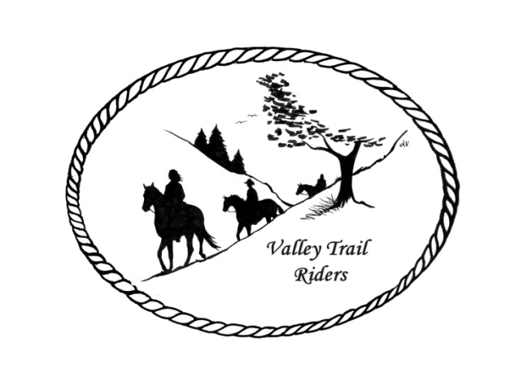 | January 2025  Newsletter

VALLEY TRAIL RIDERS CLUB NEWS

Happy New Year!! Hope you all had a fun filled holiday season and a healthy start to the new year!! Please welcome Jim & Melinda Temple, Karen Turner, and David, Katina, Chloee, and Breanna Huttenlocher as our newest members!!
The Valley Trail Rider’s end of year Christmas Party/banquet was quite a hit again this year!! We enjoyed dinner provided by Mission BBQ and dancing to the “Just 4 Fun” band. The silent auction was huge with over 50 items/baskets donated, which alone brought in over $1500!! The net profit on the event was $408.03. Thanks to all who planned and helped with the party and donated items!! The auction really helps to keep costs down for reservations for the party.
Please note that membership dues are to be in to the Treasurer Rose by January 31st. You can bring your check to the January meeting or mail it to be received by the end of the month. We need a volunteer to be the liaison to Franklin Creek State Park. Please let an officer know if you are interested.
The minutes from the previous monthly meeting and the monthly Treasurer’s report are included in the monthly mailing/emailing of the newsletter. Please review these documents prior to the meeting, as we will dispense with the reading of the reports at the membership meetings going forward. These routine reports will be approved in one motion, as distributed and read on your own, unless there are any corrections that take place at the membership meeting. There was no monthly meeting in December, so the only report attached will be the Treasurer’s report.
Officers: President -Lorrie Busby (815-973-2192); Vice President -Yvonne Comm (847-409-8678); Secretary - Caron Paschke (815-289-9389); Treasurer - Rose Shedd (815-979-5998)
Club Board of Directors for 2025: Diane Feuillerat (815-980-6777), Sharon Vonderheide (815-509-4942), and Donna Howland (815-222-7345)
Any questions or concerns can be directed to an officer or director at any time.
DUES - Single -$15.00 & Family-$20.00 Make checks payable to Valley Trail Riders and mail to: Rose Shedd, 6744 Freeport Road, Rockton, IL 61072-9426
Current member’s dues are due in hand by January 31, 2025. If they are received after that date, there will be a $5.00 fee if not received by March 1st.

Miles by the Minute ride badge program fees are also due by January 31st.

Calendar
- January Meeting on the 14th at the Lockwood Cookhouse @ 6:30. It is located at 5201 Safford Road, Rockford. We will have a discussion/hands-on help with navigating media/communications and website and emails, using phones and computers. So come with your phones and laptops if you wish. Soup will be provided by the Social Committee and members asked to bring a dish to pass.
- February Meeting on the 11th at the Lockwood Cookhouse @ 6:30. It is located at 5201 Safford Road, Rockford. We will have a guest speaker on “The Tellington Touch”. Book swap (bring a book –take a book) If you want your book returned, please put your name in it. Also, bring a sweet treat to share if you like.
- February 22nd – Game Day at the Busby Barn. Potluck at noon and games to follow.
- March Meeting on the 11th at the Lockwood Cookhouse @ 6:30. It is located at 5201 Safford Road, Rockford. Veterinarian Guest Speaker and corned beef provided by the club – bring a dish to pass (think green😊)
- April Meeting on the 8th at the Lockwood Cookhouse @ 6:30. It is located at 5201 Safford Road, Rockford. Food and activity to be announced.
- April 26th we will sponsor a clinic at Donna Howland’s arena if there are at least 10 participants signed up. Mary Hougan of EquiStroke will be speaking and demonstrating an “Intro to Liberty.” This will be an audit only event with a registration fee of $50. Please contact Lorrie @815-973-2192 if you are interested.
- May Meeting on the 13th at the Lockwood Cookhouse @ 6:30. It is located at 5201 Safford Road, Rockford
- May 17th will be our clean-up day at Rock Cut Equestrian Park and trails. Matt and Lesley Wheeler will be heading this up and more details to come in the future.

Committee Members:

Christmas Party: Caron Paschke (Chair), Debbi Hamilton, Yvonne Comm, Rose Shedd, Lorrie Busby, and Susan Krug

Social Committee: Yvonne Comm (Chair), Diane Feuillerat, and Lorrie Busby

Ride Committee: Liz Longenecker (Chair), Donna Howland, Cindy Edwards, Melissa Myers, and Chris Darmon

Social Media Committee: Webpage Administrator-Terry Busby; FaceBook Page Administrator– Kurtis Longenecker; Media Assistant -Melissa Myers

Ad Hoc Committee: (Associate Memberships) – Melissa Myers (Chair), Lorrie Busby, Caron Paschke, Chris Darmon, and Terry Busby.
Liaisons to our local parks:
Rock Cut State Park: Terry Herbig – To report any problems at the park call 815-979-1237
Franklin Creek State Park: Linda Odom & Winnebago Forest Preserves: Debbi Hamilton

Club Website Manager – Terry Busby --To contact Terry, please go to the website and click on support or email support@ valleytrailriders.club.
The website address is: www.Valleytrailriders.club To access the members-only side of the website, Click on the join button--Fill out the form --Click the Submit button. Terry will approve your access to the “Members Only” section once he verifies your paid membership. When you are approved, you will be set up with your own club email address that links to your personal email address. The Member’s only side includes: Area to submit Blog articles, club newsletter and meeting minutes, Member contacts and Club Bylaws etc…. If you have not done so yet, please go on our website and create your member log in.

Facebook Page Administrator- Kurtis Longenecker -- Please forward anything you want posted, such as pictures or events on our page to Kurtis at k_longenecker@valleytrailriders.club

There is an area to do a review on our Facebook Page. Please consider entering one! To write a review on Facebook: Go to Valley Trail Riders Facebook page; Under Posts tab or About tab
Click on *% recommend (# Reviews); Some phones may require scrolling to right of reviews listed and click on see all; Click on Yes under Do you recommend Valley Trail Riders? Type in review and share.
There is also an area at the top of the Facebook page under “more” where the tab reads “Mentions”. This will take you to past posts by members and also pictures that have been posted from events that might not show up in the feed.

Valley Trail Riders Apparel-You can purchase hats, t-shirts, sweatshirts, etc…by contacting Rose Shedd at 815-979-5998 - Rose also brings items for sale, to our club meetings😊

Annual Year End Awards:

Award Categories: (1) Most Hours in the Saddle or Driving a cart (hours include #2), (2) Most Hours in the saddle or driving a cart at VTR Hosted Events, (3) Most Active Event Organizer/Committee Member/Board Member/Officer, (4) New Member Recruitment, (5) Website Blog Activity and Finally
(6) Member of The Year based on points accumulated from the 5 categories listed above.

All VTR members are automatically eligible for this program upon payment of your annual membership dues. Points from the above categories are calculated and assigned points based on the 12-month period from November 1st to October 31st. Each of the (5) categories is awarded to first and second place. Please use the website https://valleytrailriders.club to self-report hours and activities by November 15th of each year. An alternative manual form is available on the website or from the ride committee. Please contact Donna Howland at 815-222-7345 should you require assistance.

Miles by the Minute Badge Program:
Riding and cart driving hours are calculated from 11/1 to 10/31 You will self-report your hours to Melissa Myers @ 815-494-6595 by 10/31 every year. Applications are submitted by 1/31 every year with yearly fees. The first-year cost is $25 and $15 every subsequent year. You will receive your hoodie when you sign up. Award badges will be presented at the annual Christmas Party. Awards and prizes are subject to change.

